Unit 6.5 – Day 2 Practice Name:
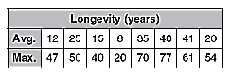
2. The table shows the average and maximum longevity of various animals in captivity.

a. Draw a scatterplot and determine, what relationship, if any, exists in the data.

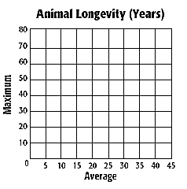

b. Draw a line of best fit and find the equation of the line.

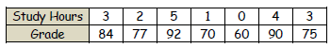
3. The table at the right gives the number of hours spent studying for a science exam and the final grade.
a. Draw a scatterplot and draw in the line of best fit.

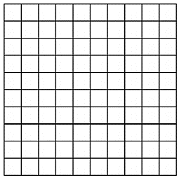
b. What is the equation for the line of best fit? Describe the correlation of the data.

c. Predict the grade of a student who
studied for 6 hours.

d. What does the slope and y-intercept mean in context of the problem?

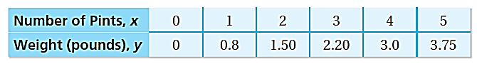
4. The table shows the weights y of x pints of blueberries.

a. Graph the data and draw a line of best fit.

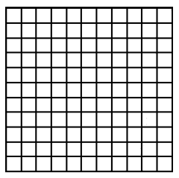
b. Write an equation of the line you drew.

c. What is a possible correlation coefficient for this data?

d. Use the equation to predict the weight of 10 pints of blueberries.

e. Blueberries cost $2.25 per pound. How much do 10 pints of blueberries costs?

