Algebra 1 Name:
Unit 7 – Day 4 Practice
1) Serena is ordering lunch from Tony’s Pizza Parlor. John told her that when he ordered from Tony’s last week, he paid $34 for two 16 inch pizzas and two drinks. Jodi told Serena when she ordered one 16 inch pizza and three drinks, it cost $23. What is the cost of one 16 inch pizza and one drink?

2) Jenna is deciding between two cell phone plans. The first plan has a $50 signup fee and costs $20 per month. The second plan has a $40 signup fee and costs $25 per month.
a. After how many months will the total costs be the same? What will the cost be?

b. If Jenna has to sign a one year contract, which plan will be cheaper?

3) The graph below shows the money saved by Lisa and Dan over the summer.
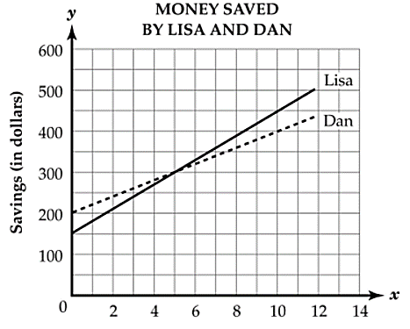
a. How long did it take for them to save the same amount of money? How much money did they both save?

b. When did Lisa have more money saved?

c. When did Dan have more money saved?

