Foundations of Algebra Name:
Unit 6 – Quiz 2 Review Part Two
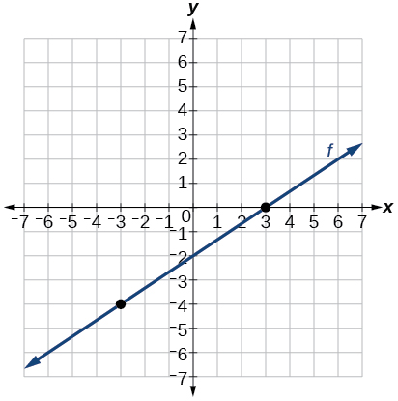 |  | 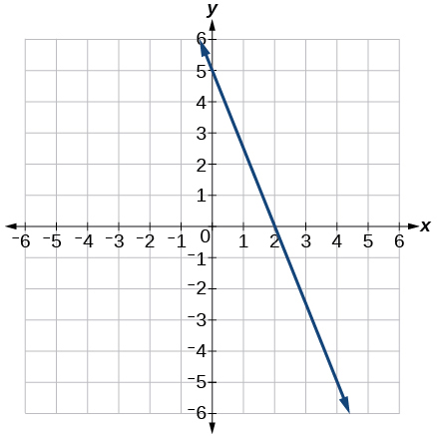
Slope: _______  X-Intercept: ______  Increasing: _______  Decreasing: ______  Constant: _______ | Y-Intercept: _______  Domain: _______  Range: _______  Positive: _______  Negative: _______ | Slope: _______  X-Intercept: ______  Increasing: _______  Decreasing: ______  Constant: _______ | Y-Intercept: _______  Domain: _______  Range: _______  Positive: _______  Negative: _______
As $x→-∞, f\left(x\right)→$ _______  As $x→∞, f\left(x\right)→$ _______ |  | As $x→-∞, f\left(x\right)→$ _______  As $x→∞, f\left(x\right)→$ _______
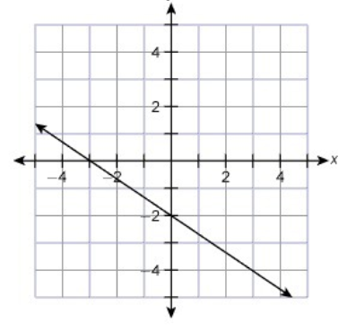 |  | 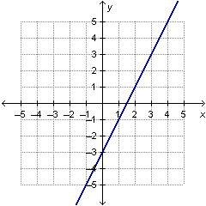
Slope: _______  X-Intercept: ______  Increasing: _______  Decreasing: ______  Constant: _______ | Y-Intercept: _______  Domain: _______  Range: _______  Positive: _______  Negative: _______ | Slope: _______  X-Intercept: ______  Increasing: _______  Decreasing: ______  Constant: _______ | Y-Intercept: _______  Domain: _______  Range: _______  Positive: _______  Negative: _______
As $x→-∞, f\left(x\right)→$ _______  As $x→∞, f\left(x\right)→$ _______ |  | As $x→-∞, f\left(x\right)→$ _______  As $x→∞, f\left(x\right)→$ _______
Find the slope and y-intercept of the following representations. Then, write the equation in slope intercept form.
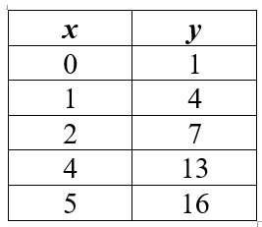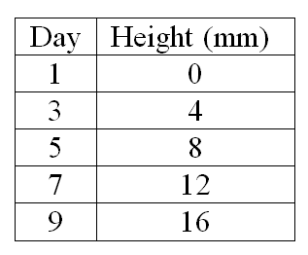

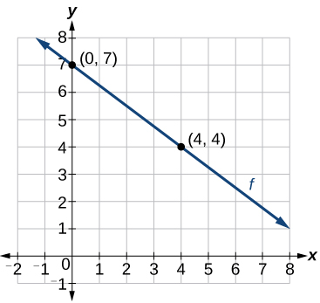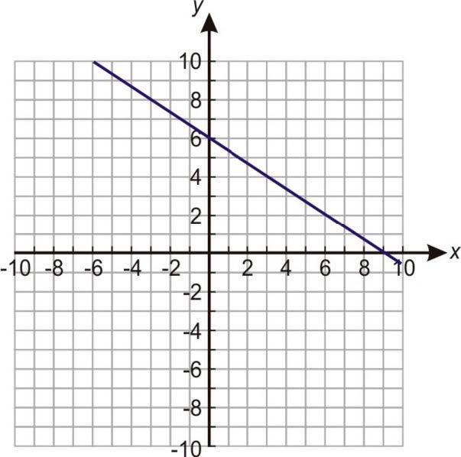

Convert the following to slope-intercept form. Then, identify the slope and y-intercept.
$2x-3y=15$ $-2x+4y=8$ $5x-7y=-14$

