Foundations of Algebra Name:
Unit 6 Day 8 – Quiz 2 Review
Sketch a graph that has a…
positive slope negative slope zero slope undefined slope
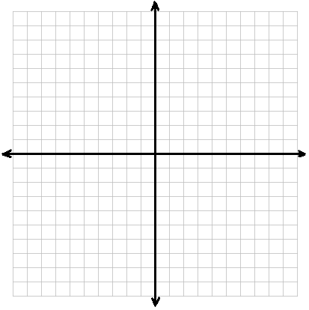

Find the slope between the following points:
$\left(0, 4\right) and (-2, 6)$ $\left(-4, 1\right) and (-2, 8)$

Find the slope from the linear functions represented below.
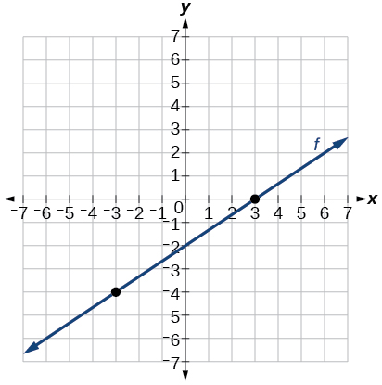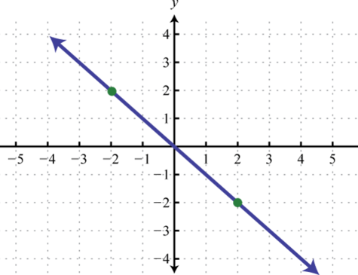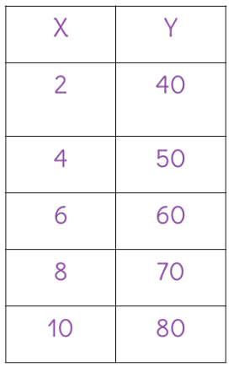

Find the y-intercepts from the functions represented below.

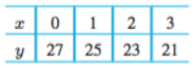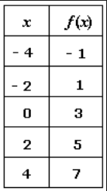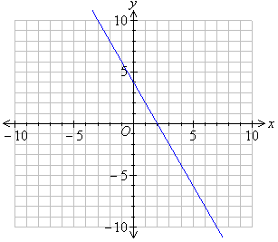

Convert the following to slope-intercept form.
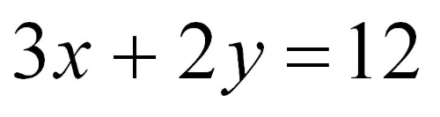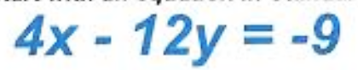

Graph the following:
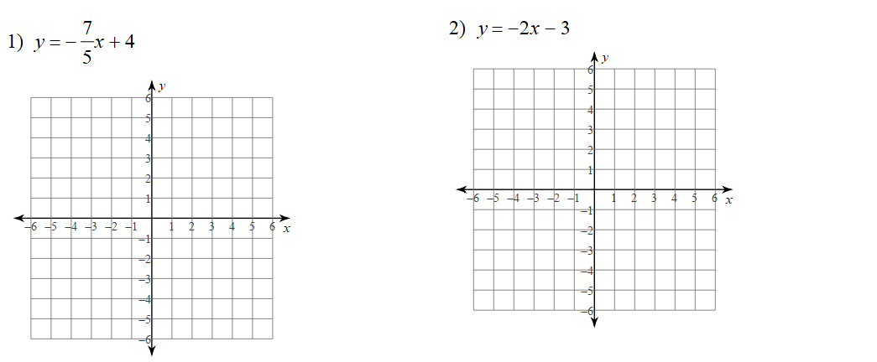

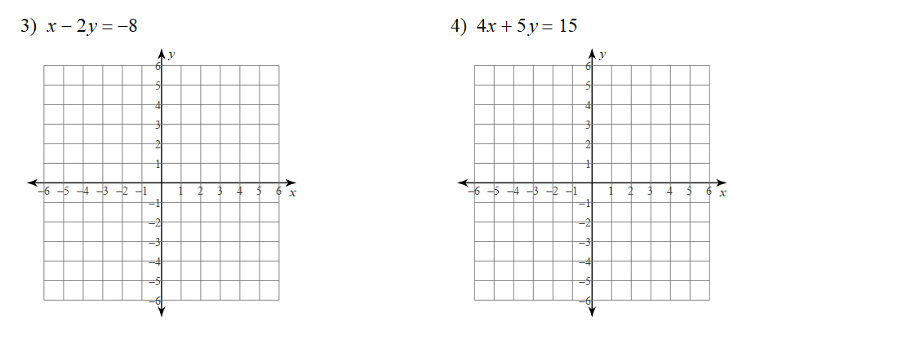

Write the equation in slope-intercept form represented by the graphs below.
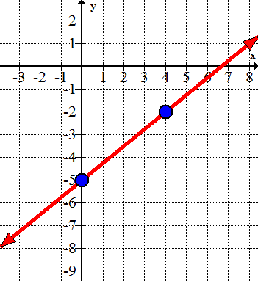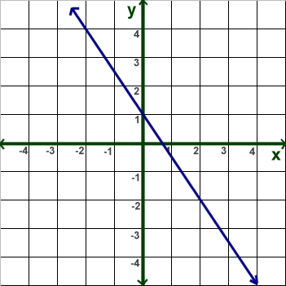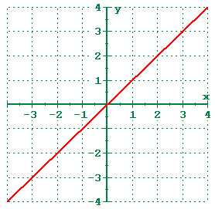
List the characteristics of the graphs below.
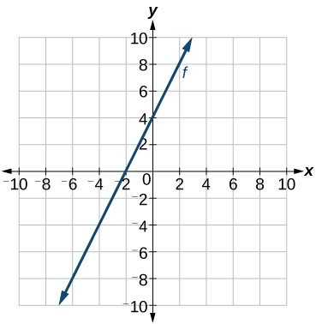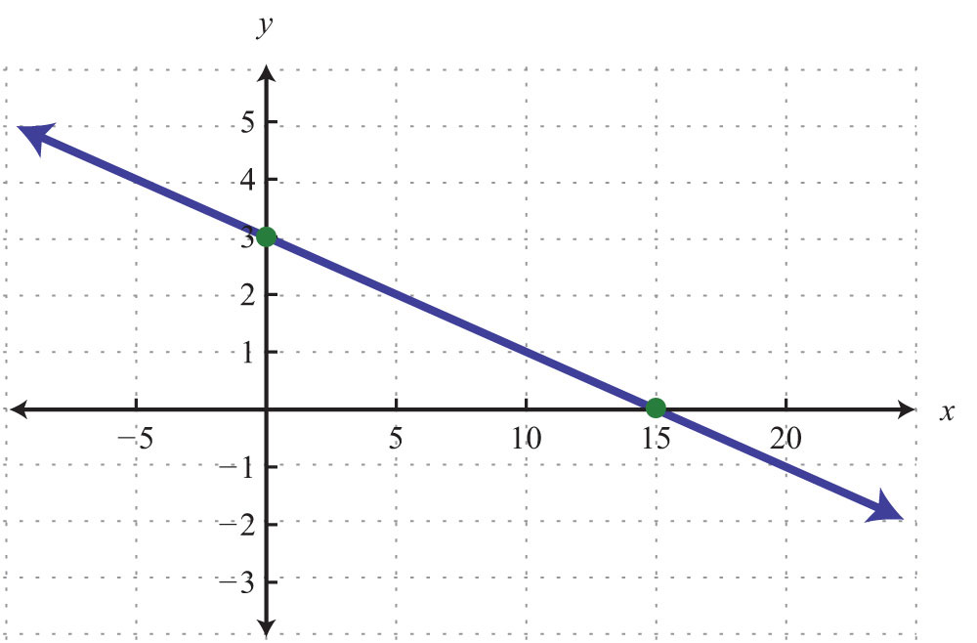
Domain: | Domain:
Range: | Positive:
Positive: | Int. of Increase:
Negative: | As $x→-∞, f(x)→______$
Int. of Increase: | Y-Intercept:
Int. of Decrease: | Range:
Int. of Constant: | X-Intercept:
X-Intercept: | As $x→∞, f(x)→______$
Y-Intercept: | Int. of Constant:
As $x→∞, f(x)→______$ | Minimum:
As $x→-∞, f(x)→______$ | Negative:
Minimum: | Int. of Decrease:
Maximum: | Maximum:

