Foundations of Algebra Unit 6
Day 7 – Characteristics of Linear Functions
One key component to fully understanding linear functions is to be able to describe characteristics of the graph and its equation. Important: If a graph is a line (arrows), we need to assume that it goes on forever.

Domain and Range
Domain
Define:  All possible values of x | Think:  How far left to right does the graph go? | Write:  [smallest #, largest #]
Range
Define:  All possible values of y | Think:  How far down to how far up does the graph go? | Write:  [smallest #, largest #]

Non Linear Examples:
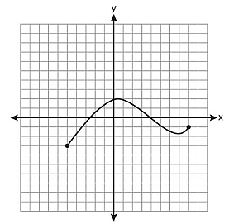
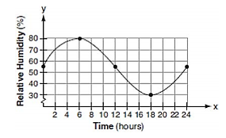
1. 2. 3.
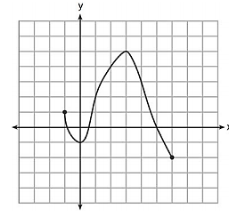

Domain: Domain: Domain:
Range: Range: Range:

Linear Examples:
1. 2.
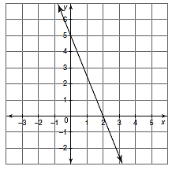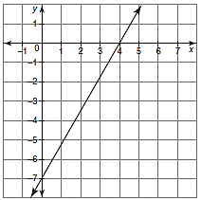
Domain: Domain:

Range: Range:

X and Y intercepts
Y-Intercept
Define:  Point where the graph crosses the y-axis | Think:  At what coordinate point does the graph cross the y-axis? | Write:  (0, b)
X-Intercept
Define:  Point where the graph crosses the x-axis | Think:  At what coordinate point does the graph cross the x-axis? | Write:  (a, 0)
Zero
Define:  Where the function (y-value) equals 0 | Think:  At what x-value does the graph cross the x-axis? | Write:  x = ____

Linear Examples:
1. 2.

Y-intercept: Y-intercept:
X-intercept X-intercept:
Zero: Zero:

3. 4.
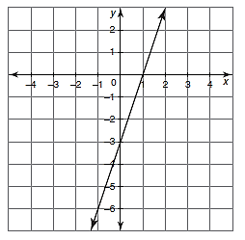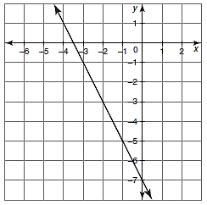
Y-intercept: Y-intercept:
X-intercept X-intercept:
Zero: Zero:

Interval of Increase and Decrease
Interval of Increase
Define:  The part of the graph that is rising as you read left to right. | Think:  From left to right, is my graph going up? | Write:  [x value where it starts increasing,  x value where is stops increasing]
Interval of Decrease
Define:  The part of the graph that is falling as you read from left to right. | Think:  From left to right, is my graph going down? | Write:  [x value where it starts decreasing, x value where is stops decreasing]
Interval of Constant
Define:  The part of the graph that is a horizontal line as you read from left to right. | Think:  From left to right, is my graph a flat line? | Write:  [x value where it starts flat-lining,  x value where is stops flat-lining]
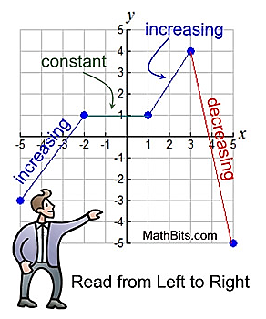
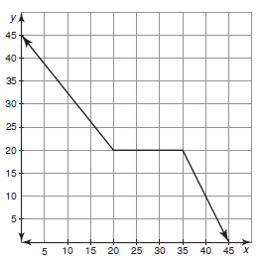
Non Linear Example:

Interval of Increase:

Interval of Decrease:

Interval of Constant:

Linear Examples:
1. 2.
Interval of Increase: Interval of Increase:

Interval of Decrease: Interval of Decrease:

Interval of Constant: Interval of Constant:

Maximum and Minimum (Extrema)
Maximum
Define:  Highest point or peak of a function. | Think:  What is my highest point or value on my graph? | Write:  y = biggest y-value
Minimum
Define:  Lowest point or valley of a function. | Think:  What is the lowest point or value on my graph? | Write:  y = smallest y-value
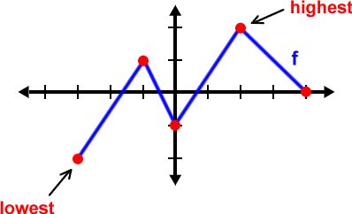
Non Linear Examples:
1. 2. 3.

Maximum: Maximum: Maximum:

Minimum: Minimum: Minimum:

Linear Examples:
1. 2.

Maximum: Maximum:

Minimum: Minimum:

Positive and Negative Regions on a Graph
Positive
Define:  The part of the function that is above the x-axis. | Think:  Which part of the function is in the positive region and where? | Write:  [smallest x-value that is positive, largest x-value that is positive]
Negative
Define:  The part of the function that is below the x-axis. | Think:  Which part of the function is in the negative region and where? | Write:  [smallest x-value that is negative, largest x-value that is negative]

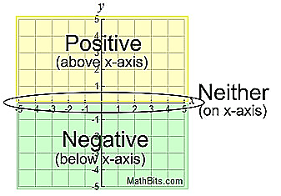
1.

Positive: __________________________
Negative: _________________________
2. 3.

Positive: __________________________ Positive: __________________________
Negative: _________________________ Negative: ________________________

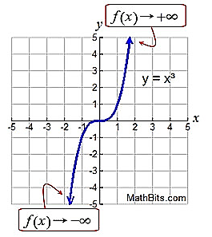
End Behavior
End Behavior
Define:
Behavior of the ends of the function (what happens to the y-values or f(x)) as x approaches positive or negative infinity. The arrows indicate the function goes on forever so we want to know where those ends go.
Think:  As x goes to the left (negative infinity), what direction does the left arrow go? | Write:  As x -$∞$, f(x) _____
Think:  As x goes to the right (positive infinity), what direction does the right arrow go? | Write:  As x $∞$, f(x) _____

1. 2.

As x -$∞$, f(x) _____ As x -$∞$, f(x) _____
As x $∞$, f(x) _____ As x $∞$, f(x) _____
3. 4.

As x -$∞$, f(x) _____ As x -$∞$, f(x) _____
As x $∞$, f(x) _____ As x $∞$, f(x) _____
Practice
Practice Example 1  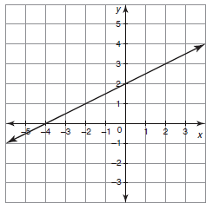 | Practice Example 2  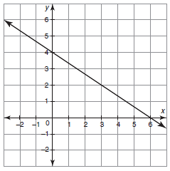
Domain:  Range: | Domain:  Range:
Y-intercept:  X-intercept:  Zero: | Y-intercept:  X-intercept:  Zero:
Interval of Increase:  Interval of Decrease:  Interval of Constant: | Interval of Increase:  Interval of Decrease:  Interval of Constant:
Maximum:  Minimum: | Maximum:  Minimum:
Positive:  Negative: | Positive:  Negative:
End Behavior:  As x -$∞$, f(x) _____  As x $∞$, f(x) _____ | End Behavior:  As x -$∞$, f(x) _____  As x $∞$, f(x) _____

