Foundations of Algebra Name: ____________________________
Unit 6 Day 4 Practice – Slopes and Y-Intercepts Date: _________________ Block: _____

Calculate the y-intercept:
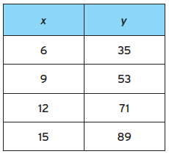
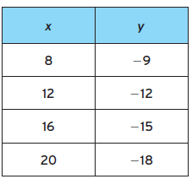
1. 2.

3. Josh received a gift card to the local movie theater. After going to 2 movies, the balance of her gift card dropped to $64. After going to 3 more movies, the balance of her gift card dropped to $40 remaining. What was her original gift card balance? Express your answer in real world terms and as a y-intercept.

4. The cost to shop a package in the mail includes a basic shipping charge plus an additional cost per number of pounds the package weighs. A three pound package costs $6.30 to shop. A ten pound package costs $14 to shop. What is the cost per pound and what is the basic shipping charge?

5. Ryan is adding water to his swimming pool. The graph below shows the amount of water in the pool as more water is added. How fast is Ryan adding water to the pool? How many gallons were in the pool to start?
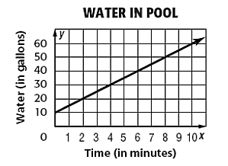
6. Frank is planning to drive his car on the Overseas Highway, the scenic road that connects the islands in the Florida Keys to the Florida mainland. Calculate the slope and y-intercept and interpret what they mean according to the problem scenario.
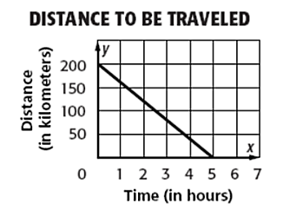
7. The graph below represents Sarah’s monthly phone charge; a monthly fee plus a charge for each minute she uses her phone. How much is the monthly fee and how much does she pay per minute?
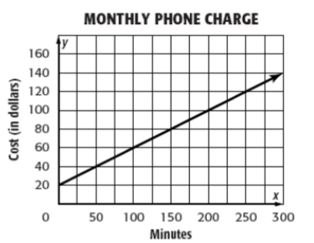
8. How many calories do you burn per minute on the exercise bike?
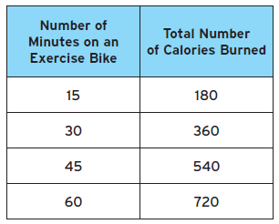
9. Carmen is selling pies at the cherry festival to raise money for her local volunteer fire department. She sells 85 pies for $12 each. The supplies to make the pies cost Carmen $340. What is the unit rate of profit she made per pie?

