**Unit 6 Name: ______________________**

**Day 1 Practice Date: ____________ Block: _____**

**State the domain and range of the relation. Then determine if the relation is a function.**

|  |  |  |  |  |  |  |  |  |  |  |  |  |  |  |  |
| --- | --- | --- | --- | --- | --- | --- | --- | --- | --- | --- | --- | --- | --- | --- | --- |
| 1.) {(1, 2), (4, 3), (5, 9), (- 2, 0)} | 2.)   |  |  | | --- | --- | | **X** | **Y** | | 8 | 1 | | 6 | 2 | | 5 | 3 | | 8 | 4 | | 7 | 5 | | 3 | 3 | |

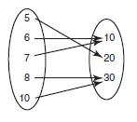3.) 4.)

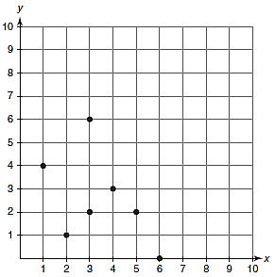

**Evaluating the function and show proper function notation:**

|  |  |
| --- | --- |
| 5.) For f(x) = 7x + 2, find f(0). | 6.) For k(p) = , find k(10). |

7.) Evaluate the function for the given values: 8.) Evaluate the function for the given values:

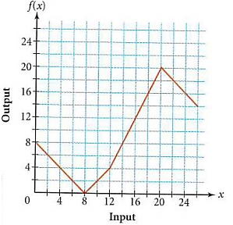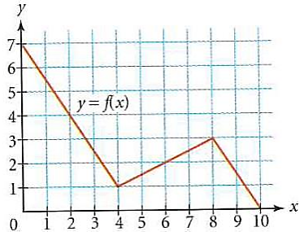

a. f(6) = _____ b. f(2) = _____ a. f(8) = _____ b. f(12) = _____

c. f(0) = _____ d. f(___) = 2.5 c. f(18) = _____ d. f(22) = _____

e. f(___) = 0 f. f(___) = 3 e. f(___) = 20 f. f(___) = 12

**Graph the linear equation using a table of value. Use – 2, - 1, 0, 1, 2 as your input values.**

|  |  |
| --- | --- |
| 9.) | 10.) |

