Foundations of Algebra Name: _______________________
Unit 6 Day 13 Practice Date: ____________ Block: _____

1. Which function has the greater slope? Which function has the greater y-intercept?
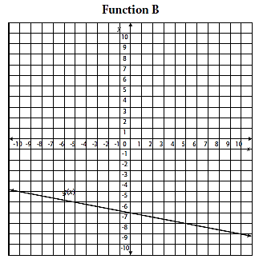
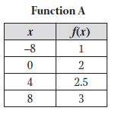

2. For the following two functions, write the equations of each and complete the chart using <, >, or = to compare them.
x | f(x)
-3 | 11
-1 | 7
1 | 3
3 | -1
5 | -5
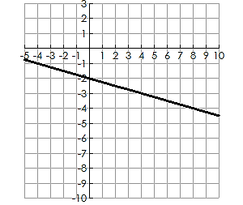
f(x) = g(x) =

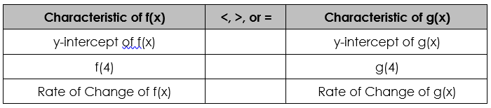

x | f(x)
0 | 4
1 | 8
2 | 12
3 | 16
4 | 20
3. You and a friend are trying to decide which theater to go to for a Friday night movie. NCG charges $7 for the movie ticket and $3 per food item. Regal’s prices are represented by the table.
a. Write an equation for NCG and Regal. Compare their slopes and initial cost.

NCG: Regal:

b. Which theater is cheaper if you want to see the movie and also get a drink and popcorn?

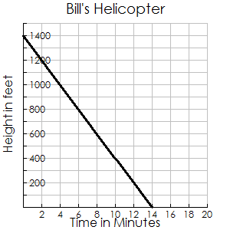
4. Two helicopters are headed toward a landing spot. Hank’s helicopter is currently at an altitude of 1250 feet and approaching the ground at a rate of 75 feet per minute. Bill’s helicopter is approaching the ground at a rate illustrated by the graph.

a. Write an equation for both helicopters.

Hank: Bill:

b. Which helicopter is descending faster? c. Which helicopter will land first? How long will it take?

5. Answer the following questions about the functions:
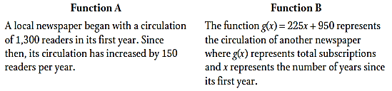
a. Which function has the larger rate of change? Explain why.

b. Which function has the higher starting amount? Explain why.

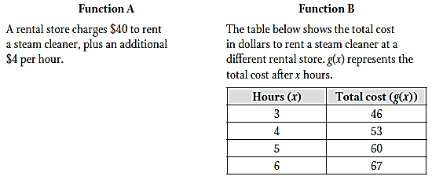
6. Answer the following questions about the functions:
a. Which function charges more per hour? Explain why.

b. Which function has the higher rental fee? Explain why.

