Foundations of Algebra Name:
Unit 5 – Day 9 Practice

Graph the inequalities on a number line:

1. m ≥ -3 2. 6 > y
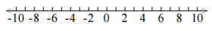

Solve and graph each inequality.
3. x - 3 > -8 4. -4x + 1 ≤ 9

Solve and graph each inequality on your own number.

5. $\frac{x}{4}-3≤9$ 6. $\frac{x-6}{4}≠2$

7. $-2m+2-3≤9$ 8. $a-6<15+8a$

9. $6+\frac{2}{3}x<4$ 10. $3\left(x-3\right)-5x>-3x-6$

9. A list of possible solutions for an inequality is shown below. Circle the solutions that make the inequality true.

Inequality: 8 ≤ -4x Possible Solutions: -2, -1, 0, 1, 2, 3, 4, 5

10. Write the inequality shown by each graph:

a. b.
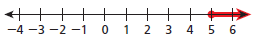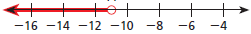

11. Which is NOT a solution of the inequality 3 – x < 2? (Show/explain how you arrived at your answer).

A. 1
B. 2
C. 3
D. 4

