Unit 4 Review Name____________________________
1. Match each characteristic to the correct graph shown. Write the letter in the box below the correct graph.
Each graph will have 4 correct characteristics.
Some characteristics may be used more than once or not at all.
A) Asymptote: $y=-1$ | B) Asymptote: $y=0$ | c) Asymptote: $y=3$
D) Domain: $(-∞, ∞)$ | E) End behavior:  As $x→-∞, f\left(x\right)→∞$  As $x→∞, f\left(x\right)→-1$ | F) Interval of Decrease: none
G) Range: $[2, ∞)$ | H) X-Intercept: $(1, 0)$ | I) Range: $[-1, ∞)$
J) Y-Intercept: $\left(0, 1\right)$ | K) Y-Intercept: $\left(0, 2\right)$ | L) Y-Intercept: $(0, 3)$

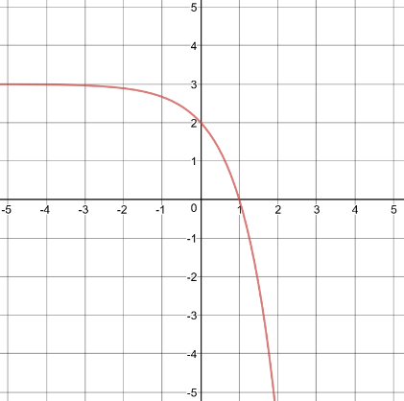 |  |  |  | 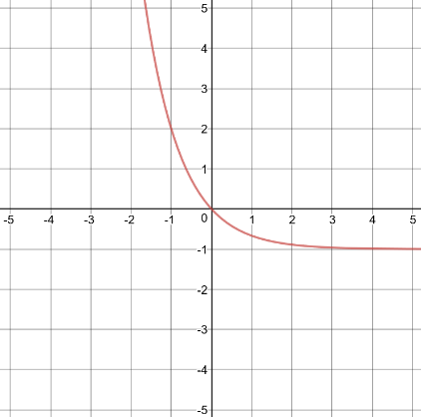 |  |  |  | 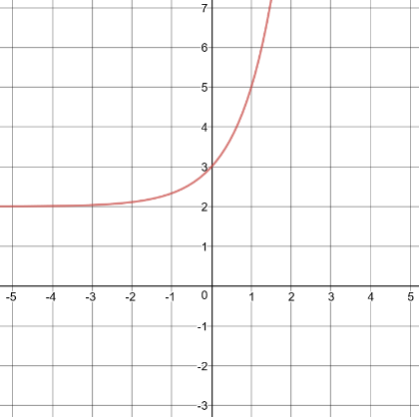
WRITE THE LETTERS OF THE CHARACTERISTICS HERE: |  |  |  | WRITE THE LETTERS OF THE CHARACTERISTICS HERE: |  |  |  | WRITE THE LETTERS OF THE CHARACTERISTICS HERE:

Graph each exponential function.
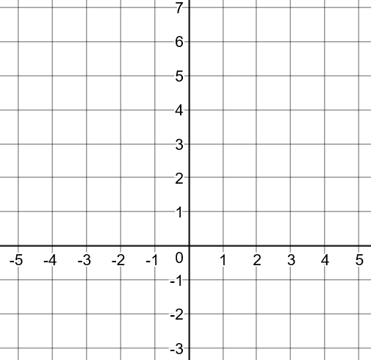
2. $y=\frac{1}{2}{(2)}^{x}+1$ 3. $y=2{\left(\frac{1}{3}\right)}^{x+1}$

$$x$$ | $$y$$

$$x$$ | $$y$$

4. The flamingo population at the zoo was 38 in 2002 and is increasing at an annual rate of 2.3%. If this growth rate continues, what will the approximate population of flamingos be in the year 2020?

5. How does the graph of the function $y=3^{x-4}$ compare to the parent function $y=3^{x}$?

6. The growth pattern of the Gremlin population can be described by the function $y=4{(2)}^{x}$, where x is the number of days. Which statement describes this situation?
- The number of Gremlins multiplies by 4 each day.
- The number Gremlins is divided by 2 each day.
- On the first day, the number of Gremlins was 4.
- On the first day, the number of Gremlins was 2.

7. Which of the following is a geometric sequence? SELECT ALL THAT APPLY. Then, find the common ratio for each geometric sequence you checked
- 12, 10, 8, 6, … r = ___
- 1, -2, 4, -8, … r = ___
- 3, 6, 9, 12, … r = ___
- 3, 6, 12, 24, … r = ___
- 64, 32, 16, 8, … r = ___
- 10, 20, 30, 40, … r = ___
- 28, -14, 7, -3.5, … r = ___

8. What is the rate of change over the interval $0≤x≤2$?
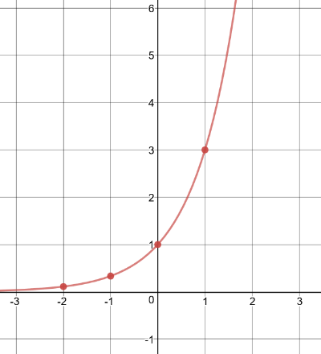
a. b. c. $f\left(x\right)=2{(4)}^{x}$
$$x$$ | $$y$$
-2 | .0625
-1 | .25
0 | 1
1 | 4
2 | 16

9. Cedric has 2 imaginary friends. Each day the number of imaginary friends triples. Use the diagram below of his imaginary friends to help answer the questions.
Day 1 Day 2 Day 3

a. Write the first 5 terms of the sequence: _____, _____, _____, _____, _____
b. Write an explicit rule for the sequence.

c. How many imaginary friends will Cedric have after 10 days?

10. Describe the transformations on the parent function, given the transformed function.
Parent Function | Transformed Function
$$y={\left(\frac{3}{2}\right)}^{x}$$ | $$y={-2\left(\frac{3}{2}\right)}^{x+7}-3$$

11. The recursive formula for a geometric sequence is $a_{n}=6(a_{n-1})$ where $a_{1}=\frac{1}{2}$.
What are the first 5 terms of the sequence?

12. Given the function $f(x)=2500{(.42)}^{x}$, determine the following:
a. Growth or Decay: _____________
b. Growth/Decay Factor: _____________
b. Growth/Decay Rate: _____________
c. $f(10)$: _____________

13. Given the geometric sequence 3, -15, 75, -375, …
a. Write an explicit equation to represent the sequence.

b. Find $a_{7}$

14. Describe the transformations of the function $f\left(x\right)=3^{x}$ to create the function $g\left(x\right)$ shown.
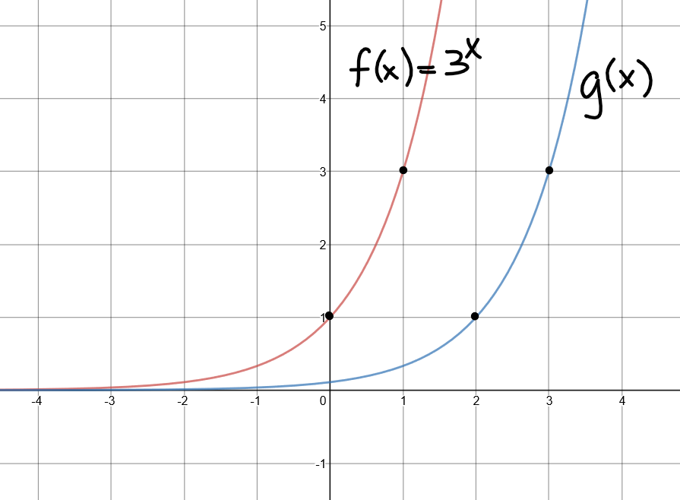

15. Jimmy deposits $3500 in an account that earns 3.2% interest per year.

- Write an exponential function to represent the scenario.

- How much money will he have in this account after 5 years?

16. Susan received some money as a gift from her grandmother. She decided to invest $1500 in a long-term certificate of deposit that earn 2.8% interest compounded quarterly. She must allow the money to stay in the account for at least 10 years. How much will the account be worth after 10 years?

17. Jay earned $2500 working with his uncle during the summer between his freshman and sophomore years. He placed the money in an account earning 4.8% interest and plans to leave it in the account until he graduates. What will the account balance be after 3 years?

18. Penny purchased a car for $12,500 in 2015. The value of the car after $t$ years can be modeled by the function $f\left(t\right)=12500{(.87)}^{t}$.
Does this model represent growth or decay?
What is the growth/decay factor?
What is the growth/decay rate?
What will be the value of the car in 2025?

19. Graph the function $f\left(x\right)=3{\left(\frac{1}{2}\right)}^{x-1}$ 20. Describe the characteristics of the function $f\left(x\right)=3{\left(\frac{1}{2}\right)}^{x-1}$
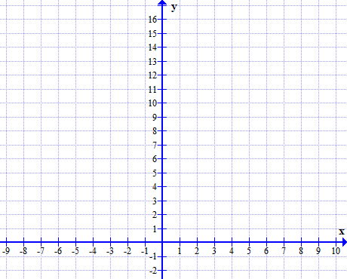
Domain:
Range:
Asymptote:
Y-intercept:
Interval of increase:
Interval of decrease:
End Behavior:
$As x→-∞, f(x)→$______
$As x→∞, f(x)→$______
f(-1) =
Rate of change over the interval $[0,1]$.

20. Match each equation or graph to the correct asymptote.
$$y=\frac{1}{3}{(2)}^{x}-1$$ | 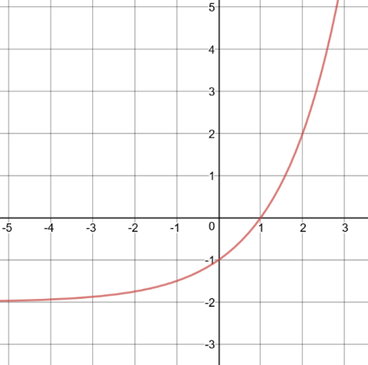 | $$f\left(x\right)={\left(\frac{1}{2}\right)}^{x-2}$$

- $y=-2$ | - $y=-1$ | - $y=0$

21. Label each function above: GROWTH or DECAY.

22. Write an explicit rule for the sequence: 500, 250, 125, $\frac{125}{2}$, …

23. The population of a certain type of bacteria started with 200 cells. After 1 day, the population was 600 cells and after 2 days the population was 1800 cells.
Write a function to describe the cell population growth over time.

How many cells will there be after 6 days?

24. If $f\left(x\right)={\left(\frac{1}{4}\right)}^{x}$, how will $g\left(x\right)=2{\left(\frac{1}{4}\right)}^{x+2}-1$ compare?
Describe the transformations.

26.. Describe the following about the function $y=3^{x+1}$
a. Transformation on the parent function $y=3^{x}$

b. Asymptote

c. Y-intercept

27. What is the common ratio of the sequence:
405, -135, 45, -15, 5, …

28. The recursive formula for a geometric sequence is $a_{n}=\frac{1}{5}a_{n-1}$ with $a_{1}=100.$
What is the common ratio for the sequence?

What are the first four terms in the sequence?

29. The explicit formula for a geometric sequence is $a_{n}=3{(-2)}^{n-1}$. What is the 8th term of the sequence?

