Foundations of Algebra Unit 4
Day 5: Multiplying Expressions/Polynomials
Before we begin, we need to go over information regarding operations.
$x+x$ = ____________________ $x-x$= ____________________ $\frac{x}{x}$ = ____________________
$x∙x$ = ____________________ $x^{2}∙x$ = ____________________ $2x∙5x$ = _______________
When multiplying two positive values, the result will be _______________________________.
When multiplying two negative values, the result will be ______________________________.
When multiplying a positive and a negative value, the result will be ___________________.
What does it mean to square something? ___________________________________________.
There are many different ways to multiply expressions and polynomials. We are going to focus on using the distributive property.
1) Distribute each term from the first expression/polynomial to every term in the second expression/polynomial
2) Combine all like terms
3) Make sure your final answer is in standard form

a) $2x(x-4)$ b) $(x+2)(x-9)$ c) ${(x-4)}^{2}$

d) $(x+6)(x-6)(x+1)$ e) $(2x+4)(3x-1)$ f) $(2x-1)(2x^{2}+x-3)$

Application Problems
The most common application problems for operations with polynomials includes finding the perimeter of a shape.
How do you find the perimeter of any shape?

How do you find the perimeter of a rectangle or square?

How do you find the area of a rectangle or square?

How do you find the volume of a rectangular prism?

1) Write an expression that represents the perimeter of the rectangle below. Then, write an expression that represents the area of the rectangle below.
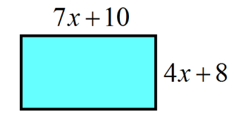

2) Write an expression that represents the volume of the rectangular prism below.
