Foundations of Algebra Unit 3 Review
Topic  1) Two Way Frequency Tables (day1 notes) | Things to Remember | Practice
1) Two Way Frequency Tables (day 1 notes) | - Joint frequencies: inside cells  - Marginal frequencies: outside cells (totals) | a) Fill in the blanks below.  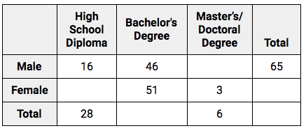
 | - To create relative frequencies, divide each frequency by the grand total – round to the nearest hundredth | b) Create a two way relative frequency table based on the two way frequency table above.
 | - How many = whole number  - Probability = decimal rounded to nearest hundredth  - Percent = percent (be sure to include % with answer) | Use either table above to answer the following questions.  c) How many people have a high school diploma?  e) What is the probability that a person has a Bachelor’s Degree? | d) What percentage of people surveyed were female?  f) What is the total number of people surveyed?
 | - Conditional probability key words: “if”, “given that”, “what percent of _____”, etc.  - You will need to divide a joint frequency by a marginal frequency  - See above for how answers should look | Use either table above to answer the following questions.  g) If a person is male, what is the probability that they have a Master’s Degree?  i) What percent of people with Bachelor’s Degrees are female? | h) What percent of people with high school diplomas are male?  j) Given that a person is female, what is the probability that they have a high school diploma?
2) Measures of Center and Spread (day 4 notes) | - Measures of Center: mean, median, mode, Q1, Q3  - Measures of Spread: range, IQR, MAD  - When finding measures of center/spread by hand, order from least to greatest first | For the data sets below, find the mean, median, mode, Q1, Q3, range, and IQR.  a) 30, 27, 24, 32, 40, 26, 37, 31, 27  Mean =  Median =  Mode =  Q1 =  Q3 =  Range =  IQR = | b) 3, 9, 5, 6, 1, 7, 1, 9  Mean =  Median =  Mode =  Q1 =  Q3 =  Range =  IQR =
 | - The smaller the MAD, the more consistent the data. | c) Data set A has a MAD of 12.5 and data set B has a MAD of 8.92. Which data set is more consistent?  d) Class A’s last quiz grades had a MAD of 4.25 and Class B’s last quiz grades had a MAD of 4.29. Which class was less consistent?
 | - Outliers are data values that are very small or very large compared to all other data values.  - No outliers = mean and range  - Outliers = median and IQR | Determine whether the data sets below have outliers; if they do, identify them. Then identify and find the best measure of center and spread.  e) 50, 45, 49, 53, 51, 52, 40, 46, 48, 58, 25  Measure of Center:  Measure of Spread: | f) 0, 12, 2, 6, 18, 3, 5,  11, 36, 9  Measure of Center:  Measure of Spread:
3) Dot Plots | - Symmetric and Uniform= mean and range  3) Box Plots (day 5)  - Skewed left/right = median and IQR | Describe the distributions below. Then identify and find the best measure of center and spread.  g) 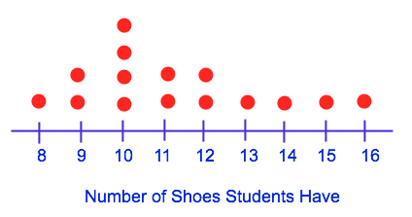  Measure of Center:  Measure of Spread: | h)  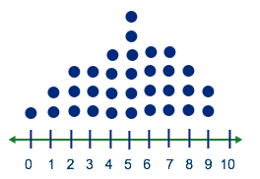  Measure of Center:  Measure of Spread:
 | - Unimodal = one mode  - Bimodal = two modes | i) Draw a dot plot that is unimodal. | j) Draw a dot plot that is bimodal.
 | - At least = that # or more  - At most = that # or less | Use the dot plot below to answer the following questions.  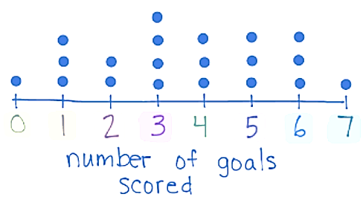  m) How many people scored less than 6 goals? | k) How many people scored at least 3 goals?  l) How many people scored between 2 and 5 goals?
4) Histograms (day 5) | - Symmetric and Uniform= mean and range  4) Histograms (day 5)  - Skewed left/right = median and IQR | Describe the distributions below. Then name the best measure of center and spread.  a)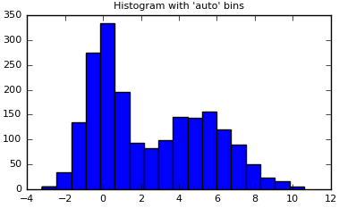  c)  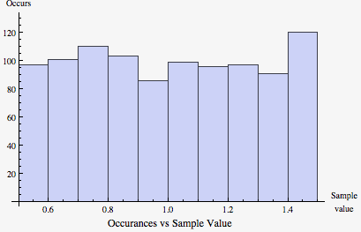  Describe what the distribution for each scenario below would be. | b) 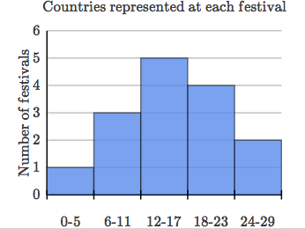  d)  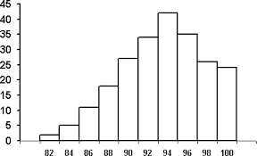
 | - Start by sketching a histogram | e) A hard Biology test. | f) Outcomes of rolling a die 1000 times
 | - Unimodal = one mode  Bimodal = two modes | g) Draw a histogram that is bimodal. | h) Draw a histogram that is unimodal.
 | - At least = that # or more  At most = that # or less | Use the histogram below to answer the following questions.  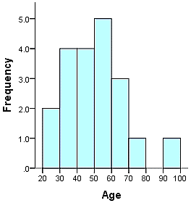  m) What age group is the most common? | i) How many people were surveyed?  j) How many people are over the age of 60?  k) How many people are at most 50?  n) How many people are between 20 and 40?
5) Box Plots (day 7) | Five Number Summary:  5) Box Plots (day 7)  - Minimum  - Q1  - Median  - Q3  - Maximum | a) Identify the five number summary of the box plot below. Be sure to include units.  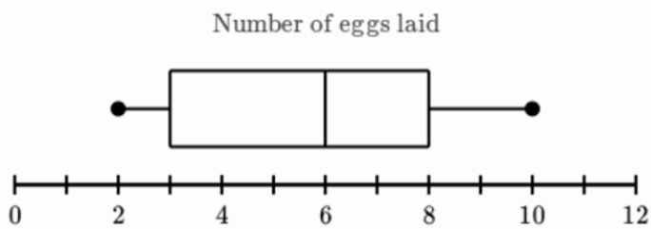
 | - Range =  max – min  - IQR = Q3 – Q1 | b) Find the range of the box plot above. | c) Find the IQR of the range above.
 | - Symmetric and Uniform= mean and range  - Skewed left/right = median and IQR | Describe the distributions below. Then identify the best measure of center and spread.  d)  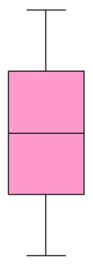  f) | e)  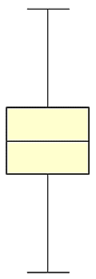  g)
 | - Min = 0th percentile  - Q1 = 25th percentile  - Med = 50th percentile  - Q3 = 75th percentile  - Max = 100th percentile  Each “section” of the box plot represents 25% of the data. | 60 people were surveyed on how many Harrison t-shirts they have. The results can be seen below. Use the box plot to answer the following questions.  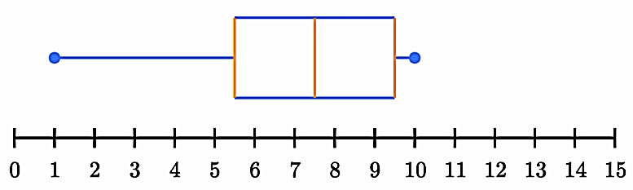  h) What percent of people have at least 5.5 shirts?  j) How many people have more than 9.5 shirts? | i) What percent of people have less than 7.5 shirts?  k) How many people have between 5.5 and 9.5 shirts?
Mixed Review
6) Coach Webb is trying to decide which two of his point guards he wants to start for the first round of play-offs. The data below shows the numbers of points scored by Jace and Tyler from the past six games.
Jace: 11, 11, 6, 26, 6, 12 Tyler: 15, 12, 13, 10, 9, 13

Who do you think Coach Webb should select as a starting player and why?

7) Which data set will have the greater mean absolute deviation? Why?

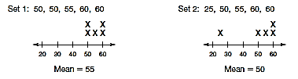

8) Determine whether the statements below are true or false based on the box plots below.

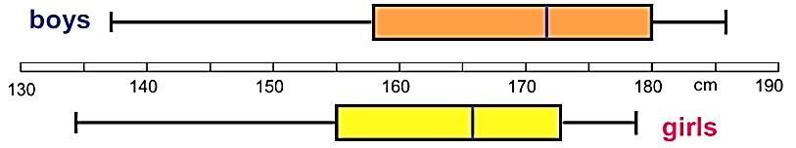

a) The girls are taller on average. ___________________

b) The shortest person is a boy. ___________________

c) The tallest person is a boy. ___________________

d) Both data sets are skewed to the left. ___________________

e) Girls have a smaller IQR. ___________________

