Foundations of Algebra Name:
Unit 3 Day 4 Practice

1. Analyze the given dot plot which displays the number of home runs by each member of the Atlanta Braves team this season so far and answer the questions accordingly.

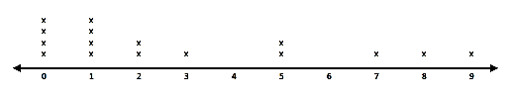

a. Describe the distribution of the data. Is the data skewed left or right? What does this mean in terms of the problem?

b. How many players are on the team?

c. How many players hit more than 2 home runs?
d. How many players hit at least 1 home run?

e. How many players scored more than 1 and fewer than 9 home runs?

2. A science teacher recorded the pulse rates for each of the students in her classes after the students had climbed a set of stairs. She displayed the results, by class, using the box plots shown.
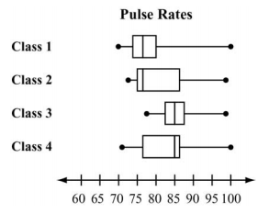
a. Which class had the biggest interquartile range?

b. Which class has the least amount of spread or variability in their data?

c. Which class had the least spread between Q₂ and Q₃?

d. Which class generally had the highest pulse rates after climbing the stairs?

