Foundations of Algebra
Unit 2 Study Guide

Name: ________________________
Block: ____________
Proportional Reasoning & Dimensional Analysis

1. I can write a ratio in several ways.
Ratio: A comparison of two quantities using division  *Order Matters when you write a ratio.  *There are 3 ways to write a ratio (1:4, 1 to 4, ¼)  *Always simplify your ratio | Your Turn  In Mrs. Dombrowski’s class, there are 5 students who own an ipad and 15 students who own an iphone.  A. What is the ratio of iphones to ipads?  B. What is the ratio of ipads to iphones?  c. What is the ratio of iphones to total students?  D. What is the ratio of ipads to total students?
For the following ratio, create two part to whole ratios:
The ratio of yellow to blue marbles is 4 to 9.

For the following ratio, create a second part to whole and a part to part.
3 out of 10 prefer math over science class.

2. I can write a ratio to compare two quantities and explain the meaning of the ratio.
What does a ratio actually mean?  Example: What is the ratio of circles to triangles?  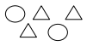  The ratio of circles to triangles is 2:3.  What does this ratio mean? For every two circles, there are 3 triangles. | A. What is the ratio of girls to boys?  B. What does this ratio mean?

3. I can determine equivalent ratios by Scaling up or down.
Scaling up: multiplying numerator and denominator by the same factor  Scaling down: dividing numerator and denominator by the same factor.  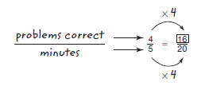 | Find the missing values:  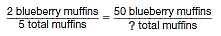  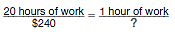
4. I can determine equivalent ratios using a double number line.
Using the number line, I can same several equivalent ratios:  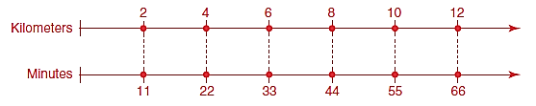 | A. You need 12 daisies for every 9 roses in your garden. Complete the double number line. How many daisies do you need for 27 roses?  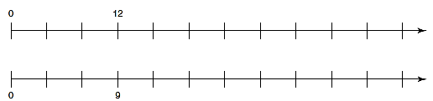

5. I can determine equivalent ratios using a table.
Ratio tables are helpful when solving word problems or if you are given a table with missing values. Think about how you can use number operations to go from each spot to another in a table. You also need to realize that each column in the table represents a ratio and they are all equivalent (hence, you can also use a proportion to find the missing numbers).  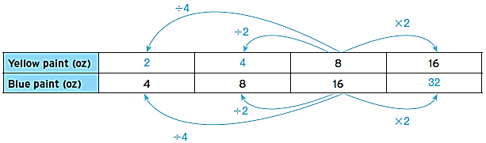 | A. Every 2 boxes of fruit snacks will serve 11 students. How many boxes can serve 22 and 33 students?  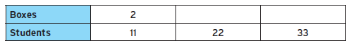  B. Each group of 5 children needs to use two soccer balls. How many soccer groups are needed for 20 and 25 groups of kids?

6. I can determine equivalent ratios using proportions.
When solving proportions, you can scale up or down OR cross multiply.  You should LABEL everything in a proportion.  Sometimes, it is best to create your part to part ratio plus the two part to whole ratios before solving to help ensure you solve what is asked of you (See I Can Statement #1). | A. in a grade level, the number of boys to number of girls is 11:5. If there are 30 girls, how many students are there total?
 | B. For every 4 seniors, there are 9 freshmen. If there are 728 students total, how many of them are seniors?
 | C. A city bus goes 18 miles in 30 minutes. How far does it go in 2 hours?
7. I can determine a unit rate.
A unit rate is the rate for one unit of a given quantity which means they have a denominator of one.  Example: Sarah reads 88 pages in 4 hours. How many does she read in an hour?  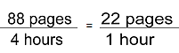  Unit rates are also useful for determining better buys (which is cheaper per unit?).  Example: Is a 12 oz bag of chocolate chips for $4 a better deal than an 18 oz bag of chocolate chips for $4.89?  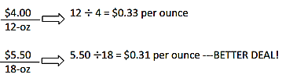 | A. Austin travels 455 miles in 9 hours. How far did he go in one hour?  B. Candy canes cost $1.50 for a dozen candy canes at Christmas time. How much is one candy cane?
C. Which is the better deal?
12 oz bottle of Diet Coke for $1.09.
20 oz bottle of Diet Coke for $1.99.

8. I can compare different representations of Equivalent Ratios & Unit Rates.
To compare different representations of ratios, determine the unit rate. | A. Jill and Katie have different part time jobs as shown below. Fill in the missing numbers and then determine how much they make per hour.  Jill:  Katie:  Who makes more per hour? How much more per hour?

9. I can convert between Fractions, Decimals, & percents.
Fractions:  - To decimals: divide numerator & denominator  - To percents: turn to a decimal and move decimal two place values to the right  Decimals:  - To percents: move decimal two place values to the right  - To fractions: place over 10, 100, 1000 (depends on your place value)  Percents  - To decimals: move decimal two place values to the left  - To fractions: place over 100 and simplify(if necessary) | Show two other forms of the following numbers (percent, fractions, or decimal):  1. 0.71 2. 0.012 3. 9%  4. 245% 5. 6.
10. I can calculate the percent, Part, or Whole of a Number.
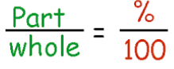  The part is normally identified by the word “is”.  The whole is normally identified by the word “of”.  The whole indicates the total or original. | Calculate the part, whole, or percent of the following statement:  1. 8% of 40 is what number? 2. 90 is 75% of what number?  3. 3 is what percent of 60? 4. 40% of what number is 26?

11. I can apply percents to real world problems.
Tax and Tip are applications that are added to our total bill.  - I can treat the tax and tip like a “part” and add the tax to my bill.  - I can also treat them as an additional percent  (100% + 7% tax rate = 107% of the bill), which calculates the final bill.  Discounts are applications that are subtracted from original price.  - If I calculate using the percent off, the number I get out is the discount that I should subtract from the original price.  - If I calculate using the percent paying, the number I get out is the price I would pay for the item after the discount.  (100% - 25% off = 75% paying for the item).  I can use the percent proportion to solve real world problems. | A. A baseball pitcher won 80% of the games he pitched. If he pitched 35 games, how many did he win?  B. Jerry, an electrician, worked 7 months out of the year. What percent of the year did he work?  C. A shirt is on sale for 20%. It originally costs $32. What is the sale price of the shirt?  D. The Gap is selling shirts for 30% off the original price. The shirts are on sale for $22.40. What was the original price of the shirt?  E. A bike is on sale for $162.50. If the original price of the bike is $250, what is the percent discount?  F. A pair of sunglasses costs $26.00 during a summer sale. If there is a 6% sales tax and Daily pays for the glasses with $30, how much change should she expect?  G. You go out to eat with your family and have a delicious meal at Mellow Mushroom. Your total bill, including a 20% tip comes to $51.47. What was the tip?

12. I can convert within the metric system.
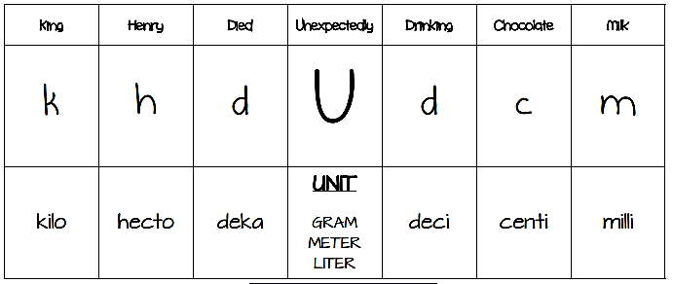  When moving the decimal to the left, you are dividing by a power of 10.  When moving the decimal to the right, you are multiplying by a power of 10.  When comparing two quantities, make sure they are in the same unit before comparing (you might have to convert one of them to the other unit first). | A. Convert the following:  1. 12.54 km = ________________ cm  2. 457 mL = ________________hL  3. 0.55 cg = __________________ g  B. Compare the following:  4. 7,225 cm _____ 72.25 m 5. 34 g _____0.34 hg  C. A recipe for shortbread cookies calls for 5 grams of butter to make 12 cookies. How many deci-grams will there be in 60 cookies?  D. A dollar bill is 15.6 cm long. If 200 dollar bills were laid end to end, how many meters long would the line be?

13. I can define appropriate units of measure.
Know your chart of Customary & Metric examples | A. For the following, give a Metric & Customary unit of measure that would best measure the following  1. height of a lamp: ___________________________________________  2. Distance from NYC to ATL: ____________________________________  3. Weight of a cat: ______________________________________________  4. Capacity of a water cooler: __________________________________

14. I can convert units of measure (1 & 2 step).
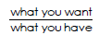  Conversion Factor:  Remember this activity:  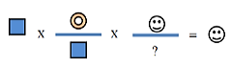  Make you practice and memorize your Customary System flash cards.  If you are going from Metric to Customary or vice versa, the conversion factor will be given to you. | A. Convert 5 miles to feet.  B. Convert 4 years into days.  C. How many miles will a person run during a 10 kilometer race? (1.6 kilometers in one mile)
15. I can convert units of measure (Multi-Step & Word Problems).
Make sure you write every single conversion factor!  Think about where you are starting and where you want to go. Create a plan that includes the necessary conversion factors.  Example: A bucket has 4.65 L of water. How many gallons of water is that (1.06 qt = 1 L).  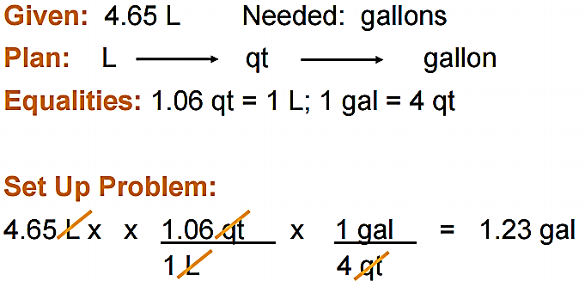 | A. Convert 12 pints to gallons.  B. Sarah ran a 10 meter race. How many feet is that? (1 in = 2.54 cm)  C. A bowl of cereal weighs 60 oz. How heavy is it in kg? (1 oz = 28.3 g)

17. I can perform a rate conversion.
Sometimes it is helpful to convert either the numerator or denominator first and then convert the other. If you do too much at once, your problem gets messy.  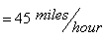  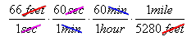  Example: Convert 66 feet per second to miles per hour. | A. Convert 65 mph to feet per minute.  B. Convert 32 feet/seconds to meters/min (1 inch = 2.54 cm).  C. The average American student is in class 330 minutes/day. How many hours per school week is this (use 1 school week = 5 days)?

