Foundations of Algebra Name:

Unit 2 Day 7 Practice

1) A student is reading a book at about 370 words per minute. Convert this rate to words per hour.

C:\Users\e198603537\AppData\Local\Microsoft\Windows\Temporary Internet Files\Content.IE5\7N38LD1Q\MC900390846[1].wmf

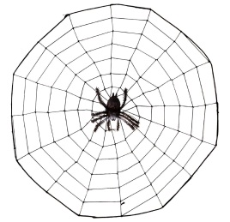2) Some female spiders have been measured spinning a web at 3 cm per second. Convert this rate to meters per minute.

3) The average speed of a car on a stretch of interstate is 70 miles per hour. Convert this rate to feet per second.

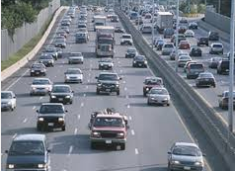



4) A piece of data on the edge of a performance hard drive platter in a computer moves at about 1319 inches per second. Convert this rate to miles per hour.

5)Craig Kimbrell can throw his fastball at 102 miles per hour. Convert this rate to feet per second.

(Challenge: It is exactly 60.5 feet from the pitcher’s mound to home plate. How many seconds would it take the ball to travel from the mound to home plate?)

C:\Users\e198603537\AppData\Local\Microsoft\Windows\Temporary Internet Files\Content.IE5\B5756Z6M\MC900030370[1].wmf6) A bathroom faucet that is fully open, usually releases water at about 95 milliliters per second. How many liters of water are released in an hour (i.e. convert the rate to liters per hour)?

7) An average typing speed for a person in a high school computer/typing class is about 44 words per minute. At this rate how many hours would it take to re-type a novel that is 45,000 words?

