Algebra 1 Name:
Unit 1 Quiz 1 Review
1 mL = 0.034 oz 1 mile = 5280 ft 1 yard = 3 ft
1 inch = 2.54 cm 73 gallons = 2 barrels 1 gallon = 4 quarts
1 meter = 3.28 feet 1 km = 0.62 miles 1 light second = 300,000,000 meters
1 kg = 2.2 lbs 1 lb = 0.45 kg 1 quart = 0.946 liters
1 ton = 2000 lbs 1 foot = 12 inches 1 in = 2.54 cm = 25.4 mm
Convert the following. Round each answer to the nearest hundredth and place your answer in the space provided.
1) Convert 0.75 yards to cm.

2) Convert 1.2 miles to inches.

3) Convert 4,580 minutes to hours.

4) Convert 1.6 weeks to minutes.

5) Convert 32 cm/sec to ft/hr.

For questions 6-10, complete the chart below.
 | Name by Degree | Name by # of Terms | Constant(s) | Coefficient(s) | Variable(s)
6)
$$2x^{2}-6x+9$$
7)
$$x^{3}+16x^{2}$$
8)
$$-4x^{3}+x^{2}+2x-1$$
9)
$$11x+7$$
10)
$${5x}^{3}+7x-2$$

Simplify each expression below. Be sure your final answer is in standard form. Circle or box your final answer.
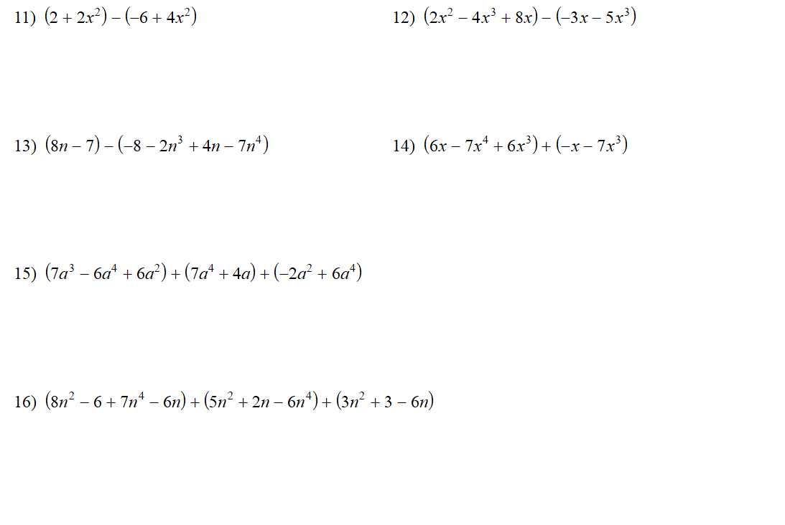

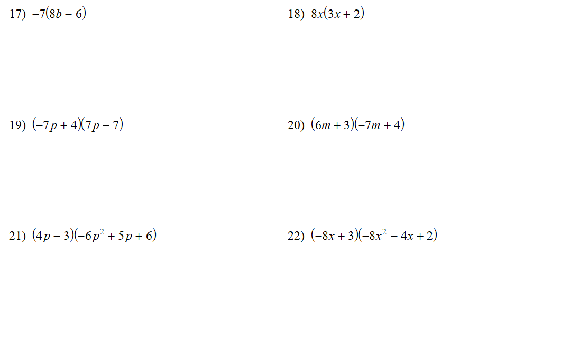
Use the figure below to answer questions 23 and 24.
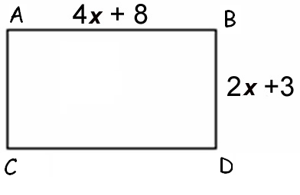
23) Find the perimeter.

24) Find the area.

