Foundations of Algebra Unit 1
Day 5 Practice
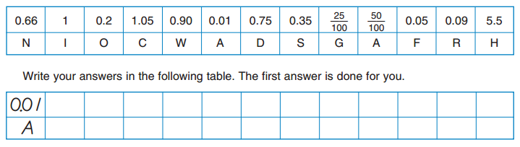
1) What’s green on the inside, white on the outsides, and hops? Put the numbers in order from least to greatest to find out.

2) Mark the appropriate locations of the decimals and fractions on the number lines below. Rename the fractions as decimals if necessary.

3) Sarah has 400 pennies and 30 dimes. How much money does she have?

