Algebra 1 Name:
Unit 11 Review
1) Graph $f\left(x\right)=2{(x-3)}^{2}-2$, list all transformations from the parent function, and identify the characteristics below.
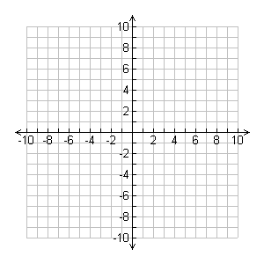
Transformations:

Vertex:
Domain:
Range:
Interval of Increase:
Interval of Decrease:
Positive:
Negative:

Y-Intercept: X-Intercepts: Zeros:
Extrema: Extrema Value:

2) Graph $f\left(x\right)=-2x^{2}+4x+6$ and identify the characteristics below.

Vertex:
Domain:
Range:
Interval of Increase:
Interval of Decrease:
Positive:
Negative:
Y-Intercept:
X-Intercepts:
Zeros:
Extrema:
Extrema Value:
3) A duck dives under water and its path is described by the quadratic function $y=2x^{2}-4x$, where y represents the position of the duck in meters and x represents the time in seconds. Round all answers to the nearest tenth.
a) What is the furthest depth that the duck reaches underwater?

b) When does the duck reach the water’s surface?

c) How far under water is the duck after 0.3 seconds?

4) Given an equation, how can you determine whether a quadratic function has a maximum or a minimum?

5) What is the vertex of the graph of $f\left(x\right)=x^{2}+10x-9$?

6) What is standard form of the quadratic function $y={(x+4)}^{2}-30$?

7) The expression $-x^{2}+70x-600$ represents a company’s profit for selling x items. For which number(s) of items sold is the company’s profit equal fo $0?
a) 0 items b) 35 items c) 10 and 60 items d) 20 and 30 items

