Statistical Reasoning Name:
The Standard Normal Distribution
As the 68-95-99.7 rule suggests, all Normal distributions are the same if we measure in units of size σ about the mean µ as center. Changing these units requires us to standardize:
$$z=\frac{x-μ}{σ}$$
If the variable we standardize has a Normal distribution, then so does the new variable z. This new distribution is called the standard Normal distribution.
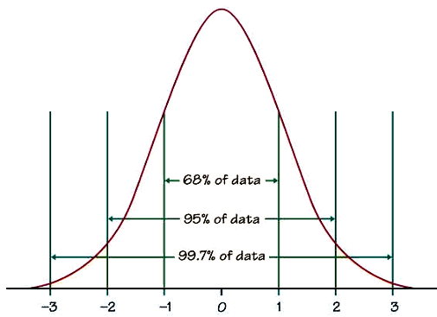
An area under a density curve is a proportion of the observations in a distribution. Any questions about what proportion of observations lie in some range of values can be answered by finding an area under the curve. In a standard Normal distribution, the 68-95-99.7 rule still applies. This means that 68% of our data lies between $z=-1$ and $z=-1.$
But what if we want to find the percent of observations that fall between
$z=-1.25$ and $z=1.25$? The 68-95-99.7 rule can’t help us.
Since all Normal distributions are the same when we standardize, we can find areas under any Normal curve from a single table, a table that gives areas under the curve for the standard Normal distribution. Table A in the back of your textbook is the standard Normal table and it gives areas under the standard Normal curve. The table entry for z is always the area under the curve to the left of z.
1) Find the proportion of observations from the standard Normal distribution that are:
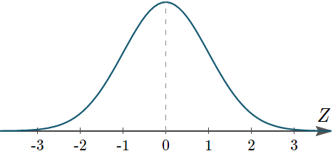
a) less than -1.25.

b) greater than 0.81.

c) between -1.25 and 0.81.

Normal Distribution Calculations
Step 1: State the problem in terms of observed variable, x
Step 2: Standardize and draw a picture
Step 3: Use the table
Step 4: Conclusion (write your conclusion in context of the problem)
Ex: On the driving range, Tiger Woods practices his swing with a particular club by hitting many, many golf balls. When Tiger hits his driver, the distance the ball travels follows a Normal distribution with a mean of 304 yards and a standard deviation of 8 yard. What percent of Tiger’s drives travel at least 290 yards?

