Statistical Reasoning Name:
Probability, Permutations, and Combinations Practice
1) There is a 25% chance of a pop quiz in Sociology each day. If quizzes are given independently of the day, what is the probability there will be a pop quiz on the next two consecutive days?

2) In a large county in Georgia, 42% of all registered voters are Democrats and 53% are Republicans. What is the probability a randomly selected voter is NOT a Democrat or a Republican?

3)Consider the following probability model associated with the number of raffle tickets purchased by each customer.
Number of Tickets | 1 | 2 | 3 | 4 | 5
Probability | 0.15 | 0.15 | ? | 0.25 | 0.25

a) What is the probability that someone buys 3 tickets?

b) What is the probability that someone buys less than 5 tickets?

c) What is the probability that someone buys at least 3 tickets?

4) A large bakery has many different products for sale. Suppose that 70% of all customers of the bakery order donuts, 50% order cinnamon rolls, and 40% order both. If a customer is randomly selected, what is the probability that the customer ordered either donuts or cinnamon rolls, but not both?

5) The following probability model describes the number of credits taken by a randomly selected first-year student at a large state university.
Credits | 14 | 15 | 16 | 17
Probability | 0.05 | 0.65 | 0.20 | 0.10

What is the expected number of credits taken by a first-year student?

6) In a class of 50 students, 30 take Philosophy, 23 take Sociology and 12 take both.
a) Create a Venn Diagram to represent this scenario.
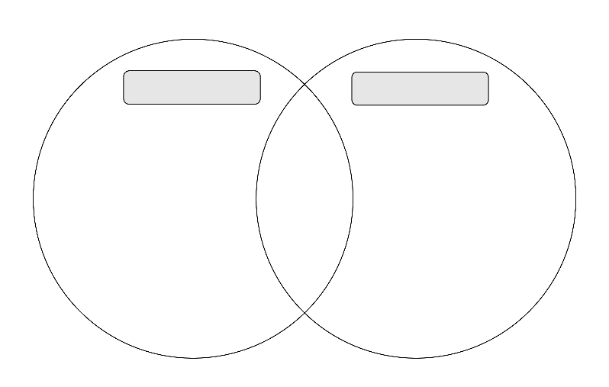
b) Find $P\left(sociology∪philosophy\right).$

c) Find $P(sociology∩philosophy)$.

d) Find $P(sociology|philosophy)$.

e) Find $P\left(not philosophy\right).$

f) Find $P(sociology or philosophy, but not both)$.

g) Are sociology and philosophy mutually exclusive? Explain.
7) If there are 9 people running in a race, how many different ways can first place, second place, and third place medals be awarded?

8) Suppose we flip a coin 3 times.
a) List all possible outcomes.

b) Let x represent the number of heads. Create a probability distribution for x.
$$x$$
$$P(x)$$

c) Draw a histogram to represent your probability distribution.

9) There are five finalists in the Mr. Universe pageant. In how many ways may the judges choose a winner and a first runner-up?

10) There are 20 members in a club. Five people are selected to go to the state conference. In how many ways can the five members be selected?

11) How many rearrangements are there of the letters in the word “great?”

12) A committee of 5 people is to be chosen from a group of 6 men and 4 women. How many committees are possible if:
a) there are to be 3 men and 2 women? b) there are to be men only?

13) In how many ways can 4 of 7 different kinds of trees be planted along a walkway?

14) You are given a 6 question quiz and are completely unprepared. If you completely guess on each question, what is probability of:
a) getting all questions right if the quiz is true/false?

b) getting half of the questions right if the quiz is true/false?

c) getting 4 questions right if the quiz is multiple choice (A, B, C, D)?

d) getting only question wrong is the quiz is multiple choice (A, B, C, D)?

