Statistical Reasoning Name:  
Normal Distributions Notes

Previously we have talked about density curves and noted that one important characteristics about density curves is that the total area under the curve is always equal to one. We then simulated rolling 300 die and 300 dice and ended up with a nearly symmetric distribution and a distribution that was nearly flat at the top, which is also called a uniform distribution.

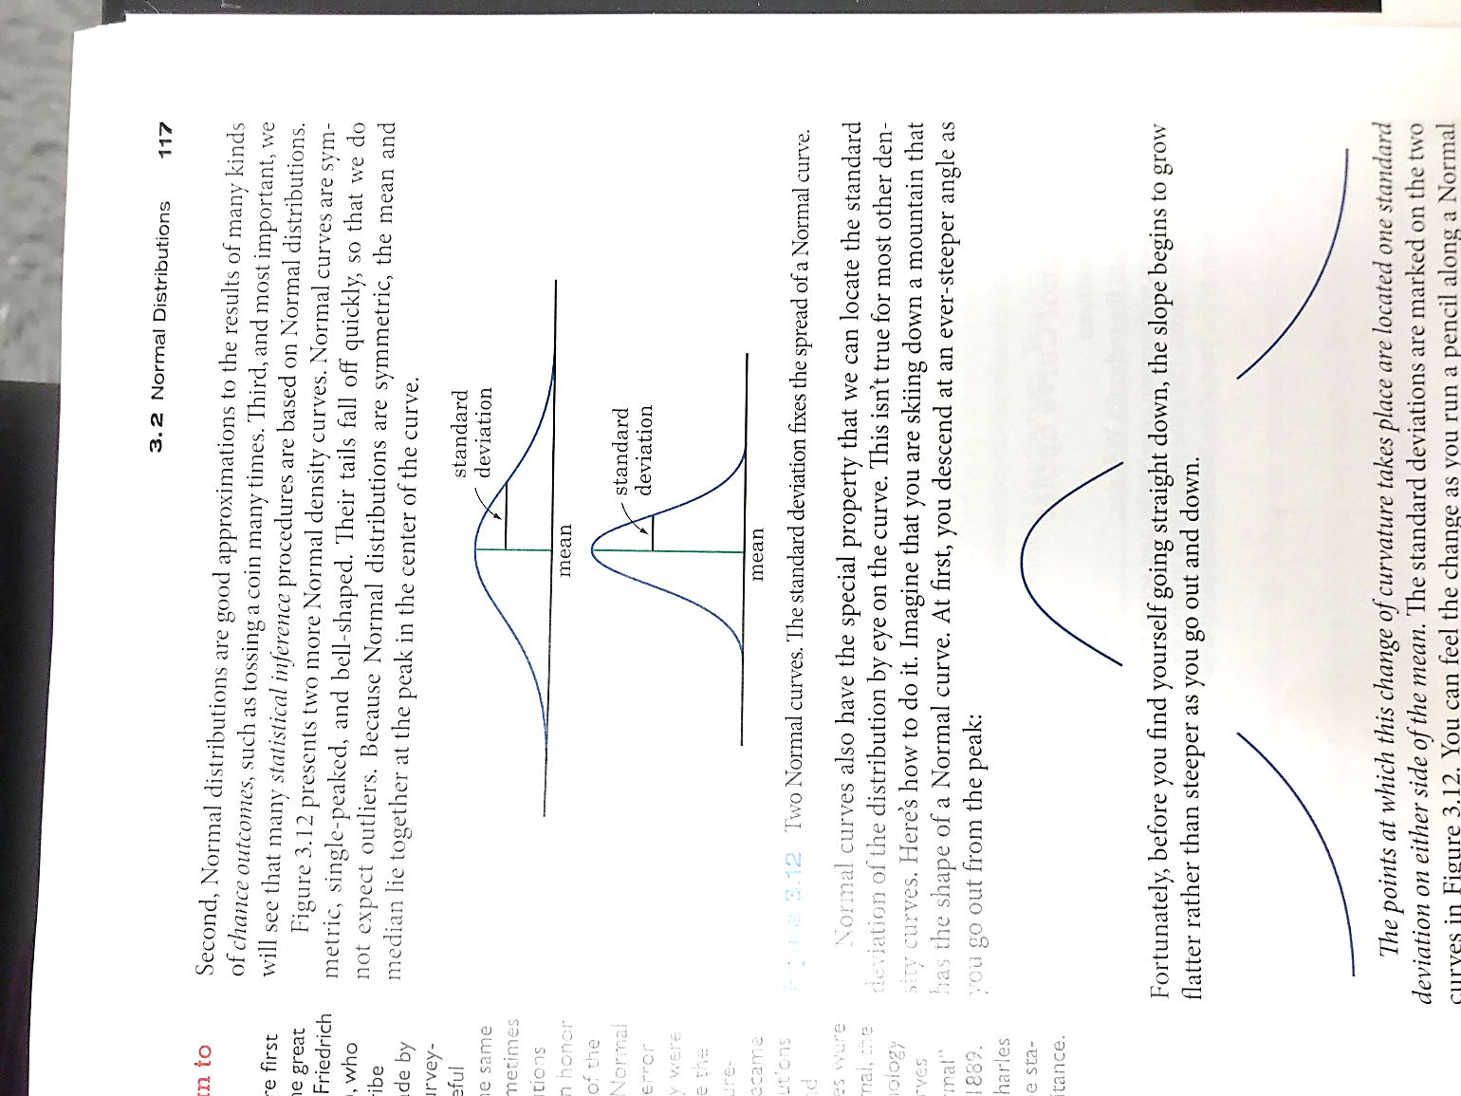One particularly important type of density curves are symmetric, single-peaked, and bell-shaped. These are known as **normal curves** and they represent **normal distributions**.

Distributions that are often close to normal include: scores on tests taken by many people (SAT, IQ tests, etc.), repeated careful measurements of the same quantity (like measuring the diameter of a tennis ball repeatedly), and characteristics of biological populations (ex: yields of corn, lengths of animal pregnancies).

**NORMAL DISTRIBUTIONS** are symmetric, bell-shaped curves with the following properties:

* a specific normal curve is completely described by giving its mean and its standard deviation
* The mean determines the center of the distribution and is located at the center of the curve
* The standard deviation determines the shape of the curve- it is the distance from the mean to the change-of-curvature points on either side

Caution! While many sets of data follow a Normal distribution, many do not.

**The Empirical Rule** – AKA: The 68-95-99.7 Rule

In any Normal distribution, approximately:

* **68%** of the observations fall within one standard deviation of the mean
* **95%** of the observations fall within two standard deviations of the mean
* **99.7%** of the observations fall within three standard deviations of the man

With your ruler, draw vertical lines with your pencil at the numbers -3 through 3.

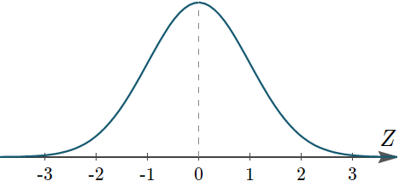

**Breaking It Down**

Again, draw vertical lines with your pencil at the numbers -3 through 3.



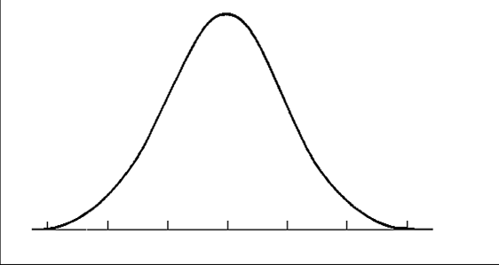Each portion of the SAT is designed to be approximately normal and have an overall mean of 500 and standard deviation of 100.

a) What percent of students will score above 700?

b) What percent of students will score below 400?

c) What percent of students will score between 600 and 800?

2000 freshmen at State University took a biology test. The scores were distributed normally with a mean of 70 and a standard deviation of 5. Label the mean and three standard deviations from the mean.

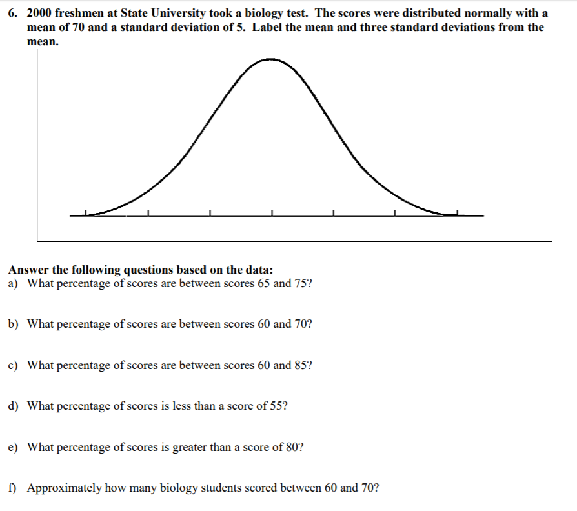

Answer the following questions based on the data.

a) What percentage of scores are between scores 65 and 75?

b) What percentage of scores are between scores 60 and 70?

c) What percentage of scores are between scores 60 and 85?

d) What percentage of scores is less than a score of 55?

e) What percentage of scores is greater than a score of 80?

f) Approximately how many biology students scored between 60 and 70?