Instructions: Create a scatter plot, find the linear regression equation (line of best fit), determine the correlation, and then make a prediction.

1. The table below gives the amount of time students in a class studied for a test and their test scores. Graph the data on a scatter plot, find the line of best fit, and write the equation for the line you draw.
Hours Studied | 1 | 0 | 3 | 1.5 | 2.75 | 1 | 0.5 | 2
Test Score | 78 | 75 | 90 | 89 | 97 | 85 | 81 | 80

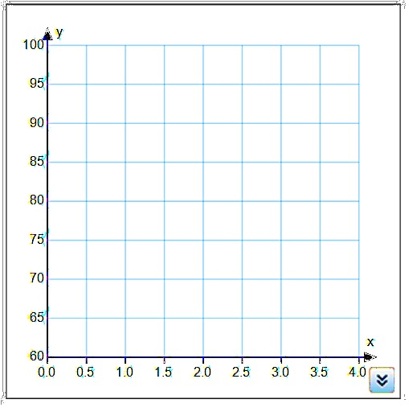
Linear Regression Equation: ____________________

Correlation Coefficient (r): _________

Type of Correlation: ______________________

Is the correlation strong? Explain

Using the linear regression equation predict
a students test score if they studied for 4 hours.

Explain what the slope means in context

2. The table below gives the estimated world population (in billions) for various years.

Year | 1980 | 1990 | 1997 | 2000 | 2005 | 2011
Population | 4400 | 5100 | 5852 | 6080 | 6450 | 7000

Linear Regression Equation: ____________________
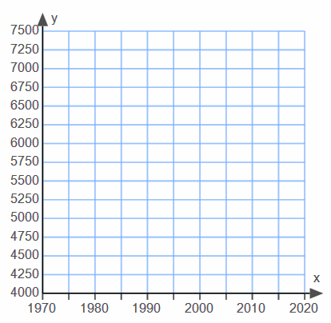
Correlation Coefficient (r): _________

Type of Correlation: ______________________

Is the correlation strong? Explain

Using the linear regression equation predict
the world population in the year 2015.

Interpret the slope in context.

