Statistical Reasoning Name:
Unit 2 Guided Notes – Dotplots and Stemplots
Vocabulary:
- Outlier –

- Center –

3. Shape –

4. Spread –

Example 1: The EPA is in charge of how fuel economy ratings for cars are determined and reported. The following table the EPA estimates of highway gas mileage for 24 model year 2009 midsize cars.
Model | MPG | Model | MPG
Acura RL | 22 | Lexus GS 350 | 26
Audi A6 Quattro | 23 | Lincoln MKZ | 28
Bentley Arnage | 14 | Mazda 6 | 29
BMW 5281 | 28 | Mercedes-Benz E350 | 24
Buick Lacrosse | 28 | Mercury Milan | 29
Cadillac CTS | 25 | Mitsubishi Galant | 27
Chevrolet Malibu | 33 | Nissan Maxima | 26
Chrysler Sebring | 30 | Rolls –Royce Phantom | 18
Dodge Avenger | 30 | Saturn Aura | 33
Hyundai Elantra | 33 | Toyota Camry | 31
Jaguar XF | 25 | Volkswagon Passat | 29
Kia Optima | 32 | Volvo S80 | 25
Create a dotplot for the data: (Label axis (MPG) and title graph, Scale and number the axis based on values, Mark a dot above the number on the horizontal axis.)

Describe the overall pattern of the distribution (shape, center, spread, outliers)
Create a stemplot for the data below.

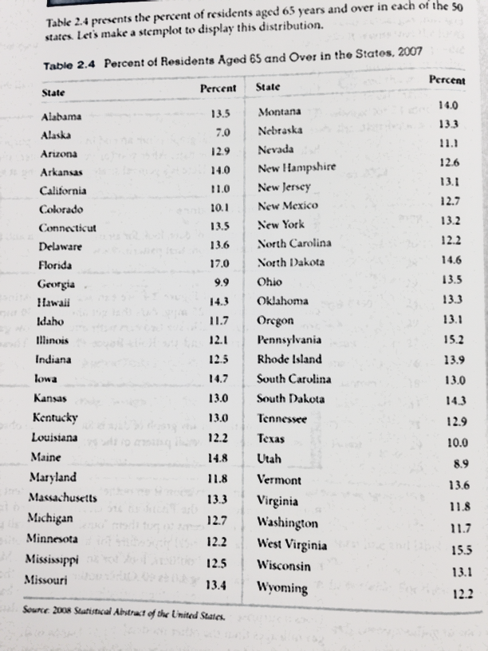

Describe the overall pattern of distribution and any deviations from that pattern.

