Statistical Reasoning Name:
3.1 – Density Curves
Read section 3.1 in your textbook about density curves, pages 107-112.
Strategy for exploring a single quantitative variable:
1) Always plot your data (usually by a ________________ or ______________)
2) Look for the overall pattern (shape, center, and spread) and for obvious outliers
3) Choose the best measure of center and spread
Skewed Left/Right: median and IQR
Symmetric: mean and standard deviation
4) When pattern is regular, use a smooth curve
The figure below represents the vocabulary scores on the IOWA test for all seventh grade students in Gary, Indiana. Draw in a smooth curve that represents this histogram. (Your smooth curve should hit some part, either the end or the middle, of most of the bars on your histogram).
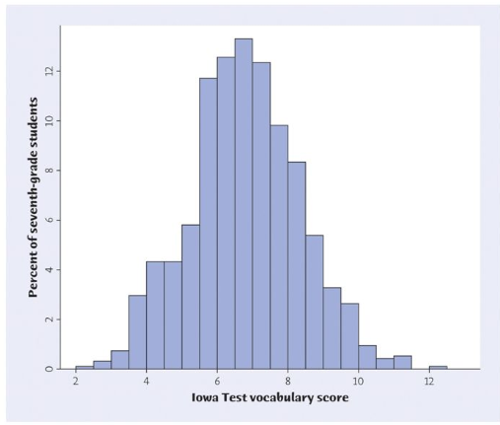
Typically, histograms show the count of observations in each class by the heights of the bars; when we change this to show the proportion of each class, we ensure that the area under the curve is 1, making it a density curve.

Center and Spread
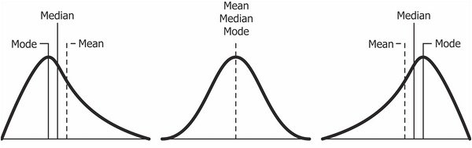
The median of a density curve is the equal-areas point. In other words, it is the point that ____________________________________________________________.

The mean of a density curve is the balance point. In other words, it is the point that would _________________________________________________ if made of solid material.
Rolling a Single Die
Follow the steps below to simulate rolling a die 300 times. Record your data below.
1: Press APPS, scroll down to Prob Sim and press ENTER
2: Find Roll Dice and press ENTER
3: Press ZOOM to change the settings
Trial Set: 300 Dice: 1 Sides: 6
Graph: Frequency Store Table: No
Clear Table: Yes Update After: End
*If it asks you if you are sure you want to continue, press Y=
4: Press GRAPH
5: Press WINDOW to roll
6: Arrow to the right to find the frequency of each roll. Complete the table below. To find the relative frequency, divide the frequency by the total number of rolls (300) and round to the nearest hundredth. Make a histogram using the number and relative frequency. Draw in a density curve.
Number | Frequency | Relative Frequency
1
2
3
4
5
6

Rolling Dice – Sum of Two Dice
Follow the steps below to simulate rolling a die 300 times. Record your data below.
1: Press APPS, scroll down to Prob Sim and press ENTER
2: Find Roll Dice and press ENTER
3: Press ZOOM to change the settings
Trial Set: 300 Dice: 2 Sides: 6
Graph: Frequency Store Table: No
Clear Table: Yes Update After: End
*If it asks you if you are sure you want to continue, press Y=
4: Press GRAPH
5: Press WINDOW to roll
6: Arrow to the right to find the frequency of each roll. Complete the table below. To find the relative frequency, divide the frequency by the total number of rolls (300) and round to the nearest hundredth. Make a histogram using the number and relative frequency. Draw in a density curve.
Number | Frequency | Relative Frequency
2
3
4
5
6
7
8
9
10
11
12

