Algebra 1 Name:
Unit 11 – Day 7 – Quiz 2 Review
1) Identify the characteristics of the graph shown below.
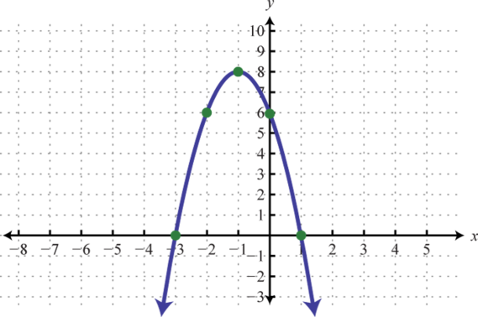
a) $(-∞, ∞)$ | b) $(-∞, -1)$ | c) $\left(-∞, -3\right)∪(1, ∞)$ | d) $x=-1$
e) $y=8$ | f) $(-1, ∞)$ | g) $\left(-3, 1\right)$ | h) $\left(-1, 8\right)$
i) $\left(-3,0\right)$ and $\left(1, 0\right)$ | j) $(-∞, 8)$ | k) $x=-3$ and $x=1$ | l) $(0, 6)$

Vertex: _____ | Axis of Sym: _____ | Domain: _____
Range: _____ | Y-Intercept: _____ | X-Intercept(s): _____
Zeroes: _____ | Extrema: max or min | Max/min Value: _____
Positive: _____ | Negative: _____
Increasing: _____ | Decreasing: _____

2) Convert the following to standard form.
$y=-{\left(x+2\right)}^{2}-6$ $y=4{(x-3)}^{2}+2$

3) Find the vertex of each of the following:
$y={2x}^{2}-8x+9$ $y={-x}^{2}+6x-2$ $y=6x^{2}+12x$

4) Identify whether each of the following have a maximum or a minimum by looking at the equation.
$y=2x^{2}-8x+3$
$y=-4x^{2}+9$
$y={-x}^{2}-x$
$y={21x}^{2}+11x+7$

5) For each characteristic below, state whether quadratics always have them or sometimes have them.
Y-Intercept:
Maximum:
Mimimum:
X-Intercept:
Increasing Part:
Decreasing Part:
Extrema:

