Algebra 1 Name:
Unit 13 – Day 6 CW Date:
For each function below, determine whether it represents a linear, quadratic, or exponential function. Then, answer the questions about the function.
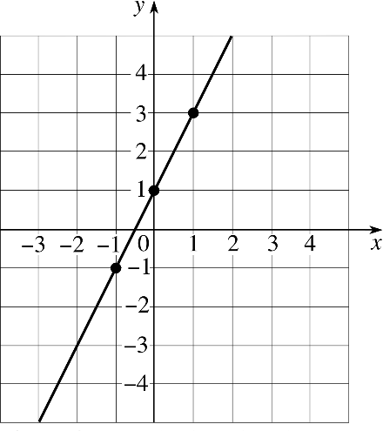
1) $y=3x^{2}-2x$ 2)

Type of Function: _______________________ Type of Function: _______________________
Y-Intercept: _______________________ Y-Intercept: _______________________
AROC for the interval $-2≤x≤1$: AROC for the interval $-2≤x≤2$:
_______________________ _______________________

3) 4)
Scientists begin their experiment with a single bacteria. Every minute, the population of bacteria triples.
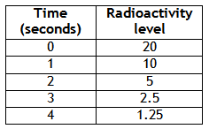

Type of Function: _______________________ Type of Function: _______________________
Y-Intercept: _______________________ Y-Intercept: _______________________
AROC for the interval $0≤x≤3$: AROC for the interval $1≤x≤4$:
_______________________ _______________________

