Algebra 1 Name:
Unit 11 Day 5 Practice
Graph the following quadratic functions given in standard form. (Unit 11 Day 5 notes)
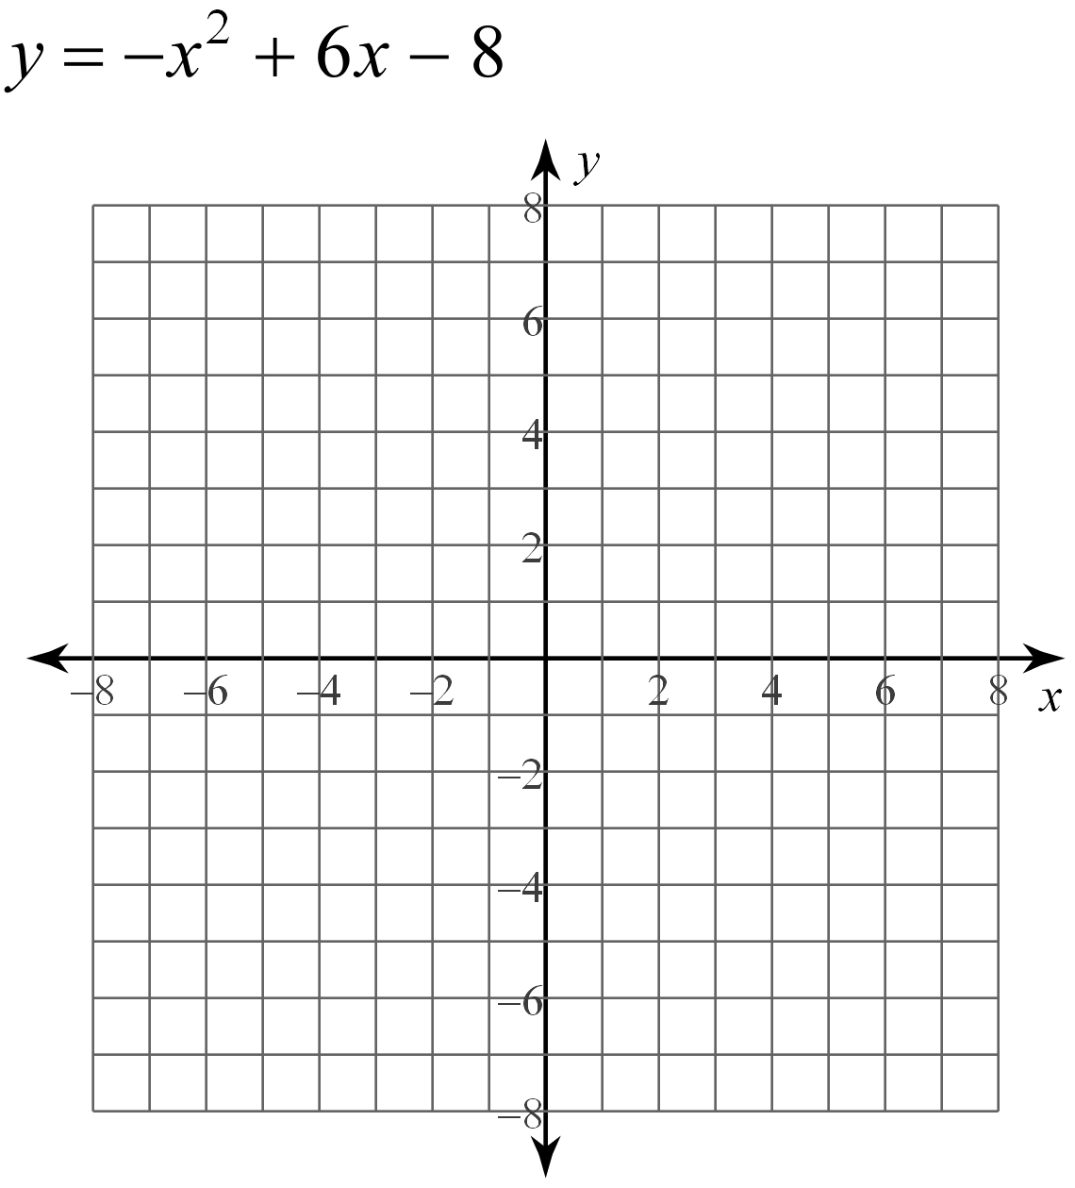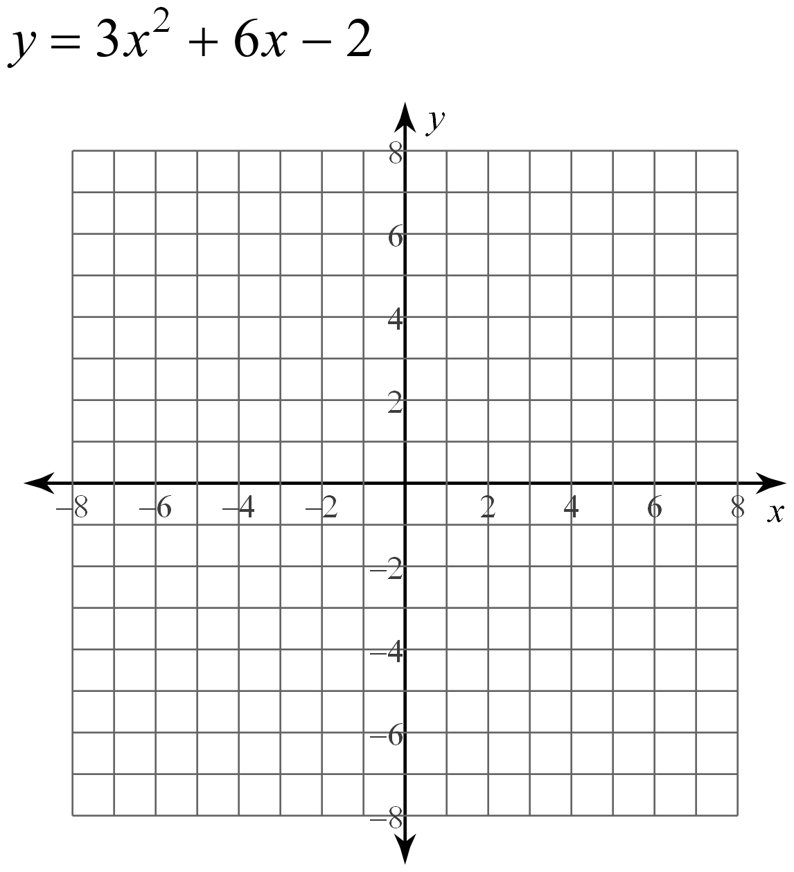

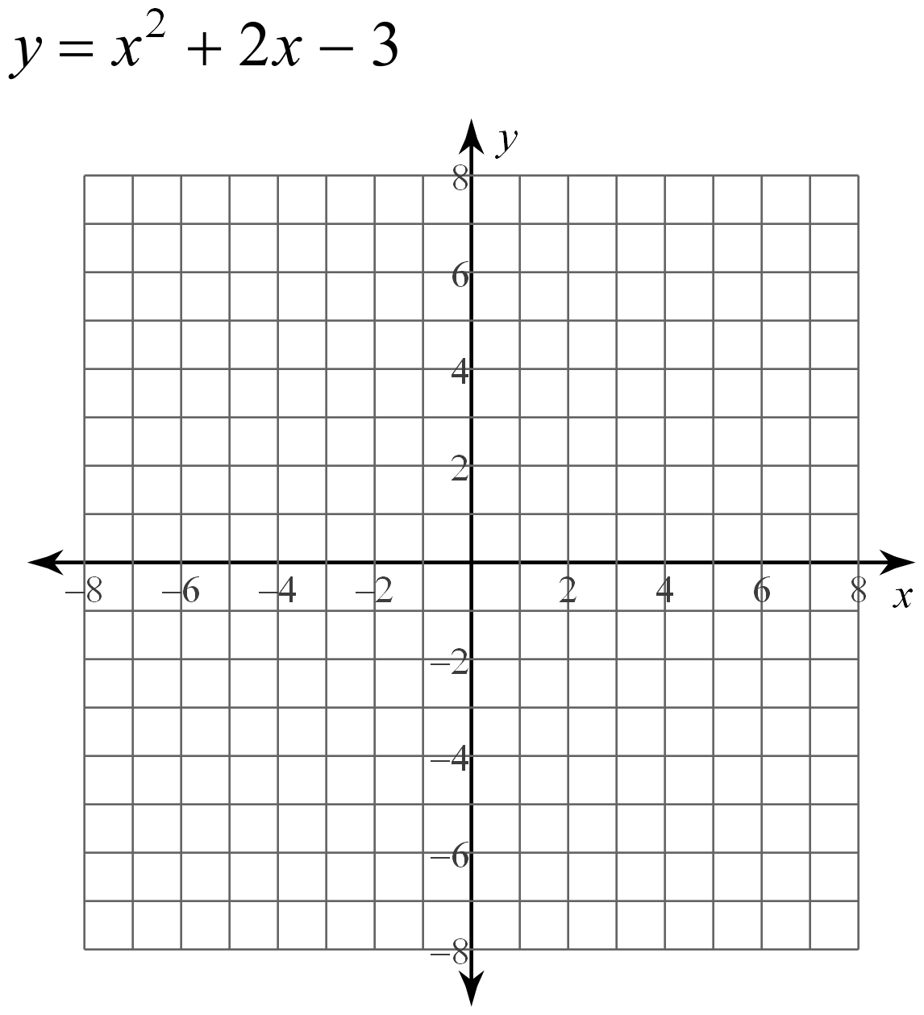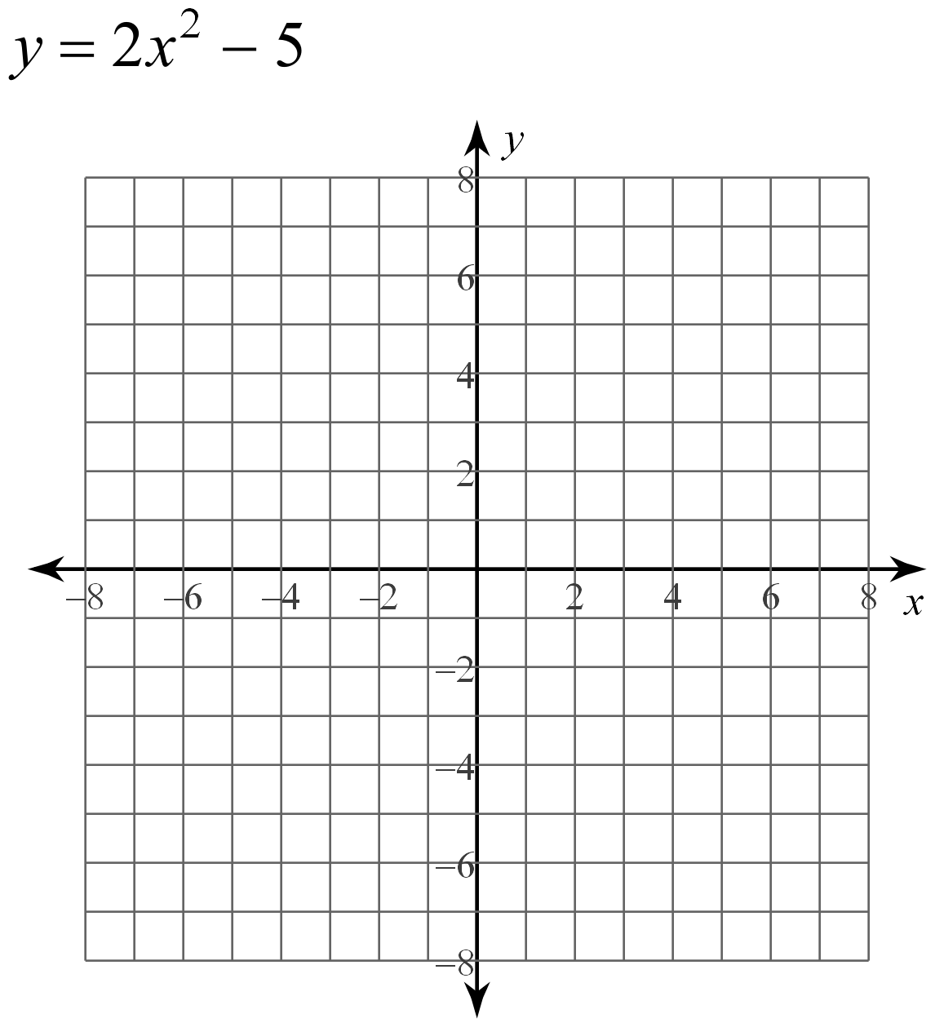

Graph the following quadratic functions given in vertex form. (Unit 11 Day 2 Notes)
