Unit 13 – Day 3 Practice Name:
1. Your employer has offered two pay scales for you to choose from. The first option is to receive a base salary of $250 a week plus 15% of the price of any merchandise you sell. The second option is represented in the graph below. Compare the properties of the functions.
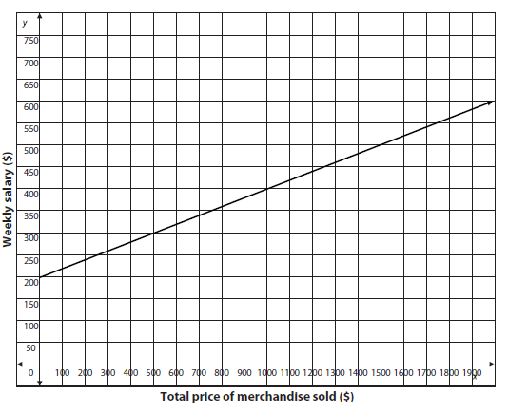
First Option

y-intercept:

slope:

Second Option

y-intercept:

slope:
a) Which function has a higher starting salary?

b) Which function has a higher commission rate?

2. Compare the properties of the functions below in terms of the problem situation:
Rental Store B
The table below shows the total cost in dollars to rent a steam cleaner at a different rental store, g(x) represents the total cost after x hours.
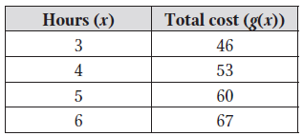
a. Which function has a higher staring price and why?
Rental Store A
A rental store charges $40 to rent a steam cleaner, plus an additional $4 per hour.

b. Which function has a higher rental cost per hour and why?
3. Compare the properties of the functions below in terms of the problem situation:
Job Offer B
She received a second job offer represented by the following equation:
f(x) = 30,000(1+ 0.02)^{x}.
Job Offer A
Jazlynn received a job offer with a starting salary of $32,000 and a 1.5% increase every year.

a. Which job has a higher starting salary?

b. Which job has a higher pay increase?

4. A bicycle store has approximately 200 bicycles in stock. The store owner is considering plans for expanding its inventory.
  - Plan A: Increase by 30 bicycles per year
  - Plan B: Increase by 10% each year

a. What type of function does Plan A represent? | b. Create a function to represent Plan A:
c. What type of function does Plan B represent? | b. Create a function to represent Plan B:

e. When will the number of bicycles under Plan B exceed the number of bicycles under Plan A?

