Algebra 1 Name:
Unit 13 – Day 2 Practice
1. Maddy and Savannah both had to have repairs done on their cars after they were in a fender bender with each other. The table and graph below show the remaining balance in dollars, f(x), of the cost of car repairs after x months. Who had the higher costs for repair and who is repaying their balance faster?

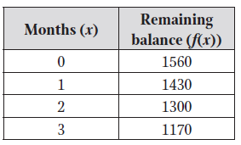
Maddy: Savannah:
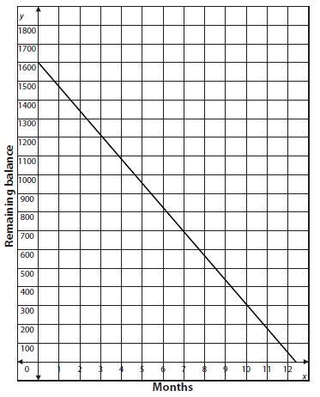

2. Which quadratic function has the lower minimum value? Explain why.
X | -4 | -3 | -2 | -1 | 0 | 1
y | 0 | -5 | -8 | -9 | -8 | -5
Function A. Function B.

3. Which quadratic function has the bigger y-intercept? Explain why.
Function A: y = -x² + 3x + 8 Function B:
X | -4 | -3 | -2 | -1 | 0 | 1
y | 9 | 13 | 19 | 13 | 9 | 7

4. Use the graph below to answer the following questions:
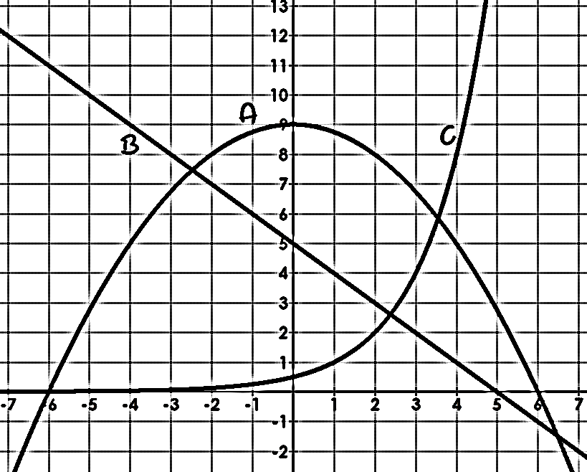
a. List the functions in order from least to greatest for y-intercepts:

b. Which function has the largest x-intercept?

c. List the functions in order from smallest to largest when x = -4.

d. List the functions in order from smallest to largest when x = 0.

e. List the functions in order from smallest to largest when x = 2.

f. List the functions in order from smallest to largest when x = 5.

g. Which graphs has the largest rate of change on the interval [-5, -3]?

h. Which graph has the largest rate of change on the interval [4, 5]?

