Algebra 1 Name:
Unit 13 – Day 1 Practice

Determine if each equation below represents a linear, quadratic or exponential function:

1. f(x) = 3x + 2 2. y = 3^{x} 3. y = 7²

4. f(x) = ½(2)^{x} + 1 5. y = x²

Determine if each graph represents a linear, quadratic or exponential function.

6. 7. 8.
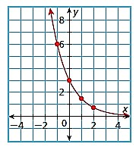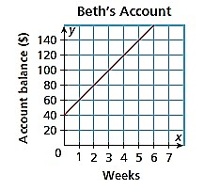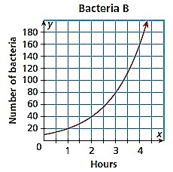

8. 9. 10.
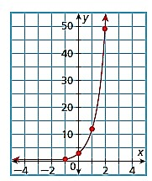
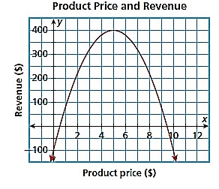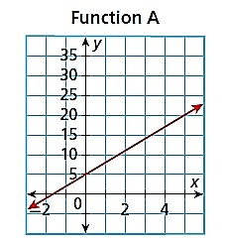

Determine if each sets of ordered pairs or tables represent a linear, quadratic or exponential function and justify why:
11. 12.
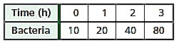
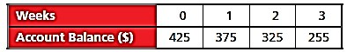

13. 14.
