Statistical Reasoning Name:
Unit 2 – Quick Review
Below is data from a sample of 28 people about what age they were when they got their first job. Use this data to answer all the questions below.
12 | 17 | 15 | 16 | 21 | 20 | 16
18 | 18 | 19 | 23 | 25 | 24 | 22
18 | 19 | 20 | 21 | 16 | 16 | 17
30 | 23 | 22 | 20 | 18 | 18 | 17

1) Find the five number summary.

2) Determine whether there are any outliers.

3) Create a box plot.

4) Find the mean, standard deviation, range, and IQR.

5) If we were to add 5 years to each age, how would the mean, median, standard deviation and IQR change?

6) If we were to double each age, how would the mean, median, standard deviation and IQR change?
The results from a pre-test for students for the year 2000 and the year 2010 are illustrated in the box plots below.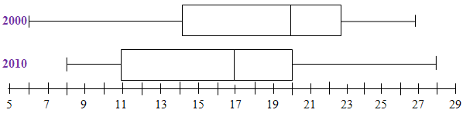
Identify each statement below as true or false.
• The median score for 2000 was higher than the median score for 2010.

• The scores from 2000 have less variety than the scores from 2010.

• 2000 had the lowest score.

• The scores from 2010 have a larger IQR.

Use the box plot from 2010 to answer the questions below.
What percent of students scored above 17?

What percent of students scored between 11 and 20?

What percent of students scored less than 11?

If there were 300 students enrolled in the class is 2010, how many scored above 20?

