Statistical Reasoning Name:
Chapter Five – Quiz Review
Section 5.1
State whether or not the sample is biased. If so, explain why, and describe a possibly way to fix it.
- A radio station wants to know what the most popular type of music is, so they ask their listeners to call in to say their favorite type.

- You want to know what high school students think of the food in the vending machines. You poll 100 random high school students.

- You want to survey the students in your school about their study habits. You poll 100 students who have at least one failing grade on their 6 week progress report.

State whether or not the statement is biased or fair. If it is biased, explain why.
- Do you want soup or a sandwich for lunch?

- Are you going to the dance like everyone else?

- In order to gauge the opinions of Ohio State undergraduate students about a proposal to raise tuition by 9% next year, the school newspaper ran an on-line poll requesting people viewing their Web site to respond to the question, “Should OSU raise tuition by 9%?” Altogether, 313 people responded; 218 (70%) said No. Give one reason why the results are likely to be biased.

7. Bob is having a BBQ and he want his friends to be happy with the meal choice. He calls 10 of the people who were invited to see how many of them want steak. If it is more than 50%, then he will cook steaks.
a) Population - ___________________________
b) Parameter - ____________________________
c) Sample - ______________________________
d) Statistic - ___________________________

8. Multiple Choice. A mayor wants to see if the people in his town think he is doing a good job. Which choice best represents the population that the mayor is interested in?
(a) All residents of the town (b) His neighbors
(c) 258 voters that he asks (d) 1,000 unemployed voters

9. Multiple Choice. A musician asks 500 people who purchased his last song whether or not they liked it. Which choice best describes the population and sample?
(a) The population is the 500 people asked and the sample is the number who said yes.
(b) The population is all people who purchased the song and the sample is the number of people who liked it.
(c) The population is all people who purchased the song and the sample is the 500 people he asked.

10. The average weight of a giraffe is 2,628 lbs. A random sample of 20 giraffes was taken and it was found that they weighed an average of 2,004 lbs. Does this give us reason to believe that reported average weight is to high? Identify the a) population b) parameter c) sample and d) statistic for the following scenario.
a. Population – _______________________________________________________________
b. Parameter – _______________________________________________________________
c. Sample – __________________________________________________________________
d. Statistic - __________________________________________________________________

11. Sale of eggs that are contaminated with salmonella can cause food poisoning among consumers. A large egg producer takes 200 eggs from all the eggs shipped in one day and sends them to be tested. The laboratory reports that 4.5% of these eggs had salmonella contamination. Unknown to the producer, 0.1% (one-tenth of one percent) of all eggs shipped that day had salmonella.
a. Describe the sample and population.

b. Is the number 4.5% a statistic or a parameter?
c. Is the number 0.1% a statistic or a parameter?

12. A carload of ball bearings has an average diameter of 2.503 centimeters (cm). This is within the specifications for acceptance of the lot by the purchaser. The inspector happens to inspect 100 ball bearings from the lot with an average diameter of 2.515 cm. This is outside the specified limits, so the lot is mistakenly rejected. Identify the parameter and statistic in this scenario.

13. A university’s financial aid office wants to know how much it can expect students to earn from summer employment. This information will be used to set the level of financial aid. The population contains 478 students who have completed at least one year of study but have not yet graduated. A questionnaire will be sent to an SRS of 100 of these students, drawn from an alphabetized list. Starting at line 135, select the first three students in the sample.
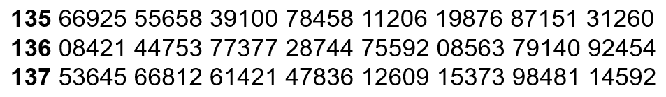

14. The list of the top 10 largest colleges in Fall 2017 as measured by undergraduate enrollment is shown below.
SCHOOL (STATE) |  | FALL 2017 UNDERGRADUATE ENROLLMENT
University of Central Florida |  | 56,972
Texas A&M University—College Station |  | 53,065
Florida International University |  | 47,586
Ohio State University—Columbus |  | 45,946
Liberty University (VA) |  | 45,754
Arizona State University—Tempe |  | 42,427
Pennsylvania State University—University Park |  | 40,835
Broward College (FL) |  | 40,754
University of Texas—Austin |  | 40,492
Michigan State University |  | 38,996

Use the random digit table below to randomly select three colleges.

15. Determine whether the following represent a simple random sample, a voluntary response sample, or a convenience sample.
a) A restaurant leaves comment cards on all of its tables and encourages customers to participate in a brief survey to learn about their overall experience.

b) A teachers puts students' names in a hat and chooses without looking to get a sample of students.

c) A TV show host asks his viewers to visit his website and respond to an online poll.

d) A researcher polls people as they walk by on the street.

e) Standing at a shopping mall and selecting shoppers as they walk by to fill out a survey

