Statistical Reasoning Name:  
Chapter 2 Review – Part 2

Match the following histograms to the corresponding box plot based on shape.







Describe the relationship between the mean and the median for each of the following types of distributions.

For a symmetric distribution, the mean is _________________________________ the median.

For a skewed right distribution, the mean is _______________________________ the median.

For a skewed left distribution, the mean is ________________________________ the median.

What are the two main measures of center that we use? When do we use each?

What are the two main measures of spread that we use? When do we use each?

Given the following information, determine whether there are any outliers.

Min = 2 Q1 = 10 Med = 14 Q3 = 20 Max = 31

Use the box plot below to answer the following questions.

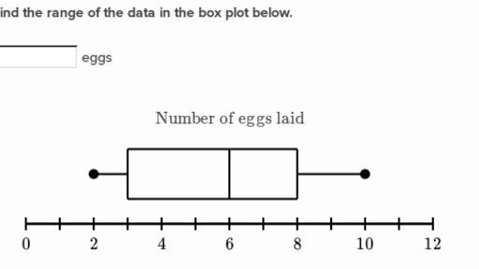

What percent of chickens lay more than 2 eggs?

What percent of chickens lay between 2 and 8 eggs?

What percent of chickens lay at most 3 eggs?

What percent of chickens lay at least 8 eggs?

What percent of chickens lay between 3 and 8 eggs?

If your data doubles, how does the mean change? How does the standard deviation change? How does the median change? How does the IQR change?

If your data all increases by 7, how does the mean change? How does the standard deviation change? How does the median change? How does the IQR change?

Identify the types of graphs below.

