Statistical Reasoning Name:
8.1 – Probability Distributions
A random variable takes numerical values that describe the outcomes of some random phenomenon. The probability distribution of a random variable gives its possible values and associated probabilities. The probability distribution can be displayed in a table or a graph. There are two important characteristics of a probability distribution:
- each probability in the distribution must be between 0 and 1
- the sum of all the probabilities in the distribution must be 1

The number of ships to arrive at a harbor on any given day is a random variable represented by x. The probability distribution for x is:
Find the probability that one a given day:
a) exactly 14 ships arrive.
b) at least 12 ships arrive.
c) at most 11 ships arrive.

Does the following table represent a probability distribution? Complete a graph to represent the information from the table, then answer the following questions.
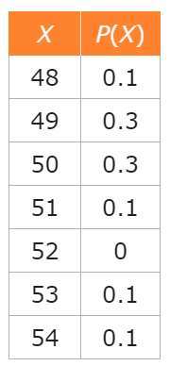
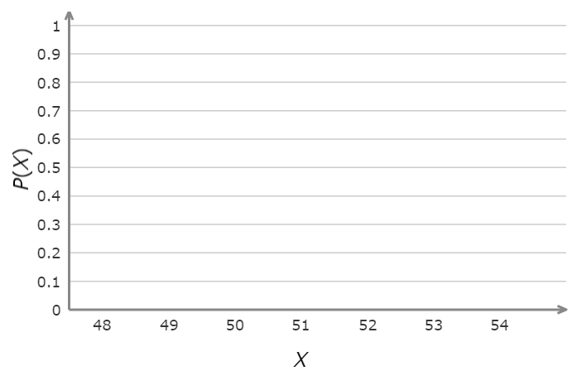
a) Find $P\left(x≤50\right).$ b) Find $P(x>53)$.

The expected value of a random variable is found by multiplying each possible value of the variable by its probability and then summing over all possible outcomes.
In symbols, if the possible values of the variable are $x_{1}, x_{2},…,x_{k}$ and their probabilities are $p_{1}, p_{2},…,p_{k}$, the expected value is:
$$expected value= x_{1}∙p_{1}+x_{2}∙p_{2}+…+x_{k}∙p_{k}$$
The table below shows a probability distribution for a random variable.
a) Find the missing value.
$$x$$ | 1 | 2 | 4 | 8 | 16
$$P(x)$$ | 0.15 | 0.25 |  | 0.20 | 0.15

b) Find the expected value of the random variable x.

For the spinner below, create a probability distribution in the form of a table and a graph. Then, find the expected value.
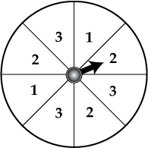

The Apgar score is a test given to newborns soon after birth. This test checks a baby's heart rate, muscle tone, and other signs to see if extra medical care or emergency care is needed. The probability distribution for scores from Apgars given one minute after birth is shown below. We can find the “average” score by finding the expected value.
The expected value is ______. This means that the average Apgar score of a randomly selected newborn one minute after birth is ________.
The Law of Large Numbers
If a random phenomenon with numerical outcomes is repeated many times independently, the mean of the observed outcomes approaches the expected value.

The sampling distribution of a statistic tells us what values the statistic takes in repeated samples and how often it takes those values.
We think of a sampling distribution as assigning probabilities to the values the statistic can take. Because there are usually many possible values, sampling distributions are often described by a density curve, such as the Normal curve.

In a recent poll of 500 registered voters, the president was given a favorable rating by 41% of the voters. Suppose that the true proportion of all adults who give the president a favorable rating is 43%. In a large number of samples, the proportionwho would give the president a favorable rating will be approximately normally distributed with mean 0.43 and standard deviation of 0.02.
a. Using the values given, label the normal curve at the right with the mean and mean ± st. dev.,
mean ± 2 st. dev. and
mean ± 3 st. dev.
b. What percent of many samples who favor the president will have a sample proportion between 0.39 and 0.47?
(Use the 68-95-99.7 rule.) ……………

c. What percent of many samples who favor the president will have a sample proportion less than 0.41? (Use the 68-95-99.7 rule.) ……………

d. What is the probability thatlies between 0.37 and 0.49? (Use the 68-95-99.7 rule.) ……………

e. What is the probability thatdoes not lie between 0.37 and 0.49? ……………

